

Dog Breeds

**of the World**

**Get your own copy of this book**

### Visit: [www.plexidors.com](http://www.plexidors.com/) Call: 800-283-8045

### Written by: Maria Sadowski



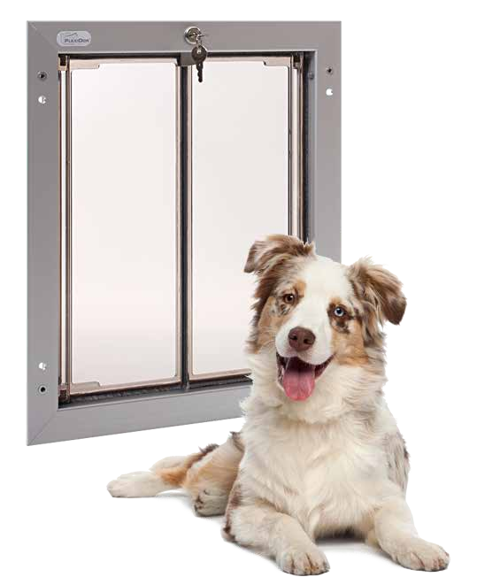**PlexiDor Performance Pet Doors** 4523 30th St West #E502 Bradenton, FL 34207

[http://www.plexidors.com](http://www.plexidors.com/)

Dog Breeds of the World is written by Maria Sadowski Copyright @2015 by PlexiDor Performance Pet Doors Published in the United States of America August 2015

All rights reserved. No portion of this book may be reproduced or transmitted in any form or by any electronic or mechanical means, including photocopying, recording, or by any information retrieval and storage system without permission from PlexiDor Performance Pet Doors.

Stock images from canstockphoto.com, istockphoto.com, and dreamstime.com

**Dog Breeds of the World**

It isn’t possible to put an exact number on the dog breeds of the world, because many varieties can be recognized by one breed registration group but not by another. The World Canine Organization is the largest internationally accepted registry of dog breeds, and they have more than 340 breeds.

Dog breeds aren’t scientifical classifications; they’re groupings based on similar characteristics of appearance and behavior. Some breeds have existed for thousands of years, and others are fairly new.

Many scientists believe the first dogs were domesticated around 16,000 years ago, but others claim evidence points as far back as 32,000 years. In the latter theory, modern dogs would be related to an ancient type of wolf that is the ancestor of both dogs and modern wolves.

Does breed matter?

The breed matters to a certain extent. Many people believe that dog breeds mostly have an impact on the *outside* of the dog, but through the ages breeds have been created based on wanted behaviors such as hunting and herding.

It is important to pick a dog that fits the family’s lifestyle. If you want a dog with a special look but the breed characterics seem difficult to handle you might want to look for a mixed breed dog.

Dogs are individuals, just like people, but being aware of a breed’s average energy level, exercise needs, or grooming needs can prevent future problems.

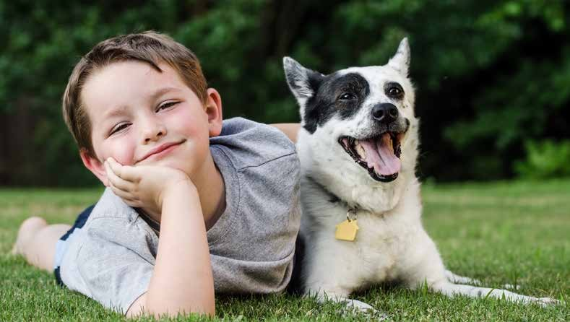

PlexiDor **Features** and **Benefits**

K-9 COMPOSITETM/MC Door Panels

Doors Open Fast and Close Tight

Large and small pets can use the same door. Panels open smoothly with a gentle push and close automatically.

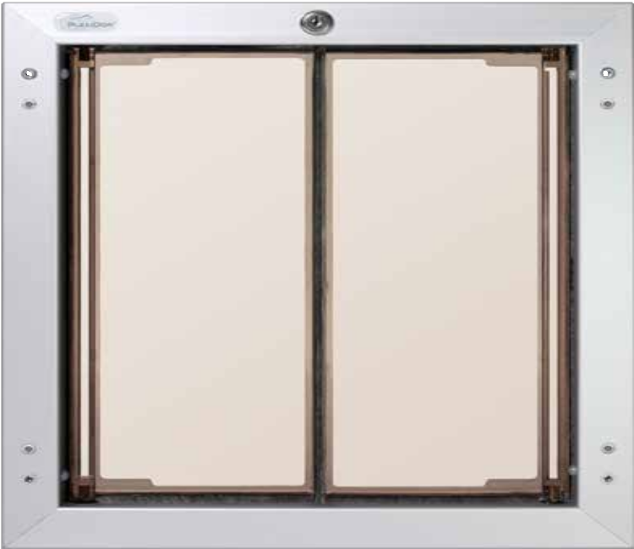

Heavy duty springs are concealed within the main frame. Doors close quietly without banging. Won’t disturb you

or frighten your pet.

Secure with Lock, Key and Security Plate

Keeps unwanted guests out of your home. Insert the key to lock or unlock the door. Apply the steel security plate when leaving for an extended period.

Maximum Energy Efficiency

The K-9 COMPOSITETM/MC panels are molded to form a“dual thermo-pane” for excellent insulation. Both panels are lined with high-density, nylon pile weather seal for superior draft-control. Doors close tight keeping the heating and cooling inside your home.

Ideal for extreme climates.

Heavy Duty Aluminum Frames



The shatter resistant saloon style door panels are manufactured with PlexiDor’s exclusive **K-9 COMPOSITE**TM/MC. The material is specially formulated to resist damage from sunlight, extreme temperatures and high impact.

Hardened aluminum interior and exterior frames won’t rust, bend, crack, or warp. Choose from anodized silver, baked on white or bronze finish. Extremely durable and look great in your home.

###### *PlexiDor® Performance Advantage*



✔ **Never purchase replacement flaps again**

✔ **Maximum energy efficiency saves money on your energy bill every month**

✔ **Secure with lock, key and security plate**

✔ **Freedom for both you and your pet**

✔ **Enjoy undisturbed sleep or uninterrupted family or TV time**

✔ **No more accidents or mess**

✔ **Peace of mind**

**90 Day Money Back Guarantee**

If you are not completely satisfied with your purchase, just return it to the dealer where you purchased it from and they will refund the purchase price in full. Shipping charges are non-refundable.

**5 Year Residential Warranty**

PlexiDor is covered by a 5 year limited residential warranty. Any defective part will be repaired or replaced without expense including standard shipping service for 5 years from date of purchase. Labor is not covered.

PlexiDor **Energy Efficiency**

### Installing a PlexiDor Performance Pet Door into your home could save you as much as 10% off your energy bill.

*Installing a PlexiDor keeps* the heating and cooling inside your home!

*Opens fast, closes tight!*

*Opening a standard sized* household door allows energy to escape.



Each time you open the door to let your dog out, your ***HEATING*** and ***COOLING*** escapes. Installing a PlexiDor can save you money every month. Review the chart below to determine your estimated annual savings.

###### *Saving 10% per month could save you $900 in just 5 years*



|  |  |  |  |  |  |
| --- | --- | --- | --- | --- | --- |
| **Your Average Monthly Energy Bill:** | **Annual Amount Spent** | **5 Year Total** | **5%**  **Savings** | **7%**  **Savings** | **10%**  **Savings\*** |
| **$100** | **$1,200** | **$6,000** | **$300** | **$420** | **$600** |
| **$150** | **$1,800** | **$9,000** | **$450** | **$630** | **$900** |
| **$200** | **$2,400** | **$12,000** | **$600** | **$840** | **$1,200** |
| ***\* Average total savings in 5 years / 60 months*** | | | | | |

***Energy savings figures***

***are based on the following:***

*An average spring/summer temperature of between 80 and 100 degrees with a household cooling temperature of 72 degrees.*

*An average fall/winter temperature of between 32 and 45 degrees with a*

*household temperature of 72 degrees.*

*Above results typical of PlexiDor owners and are based on 25+ years of Worldwide customer testimonials.*

*Actual results may vary based on household insulation, roof and window type, age and size of home.*

**Afghanistan is a country of extremes - there are high mountains with cold and thin air close to deserts. The dogs that developed in the southern and western desert regions tend to be light in color and have a sparse coat. The dogs from the north are more compact, darker, and with thicker coats.**

The Afghan hound is the most known dog breed from Afghanistan, but there is also the Afghan Shep- herd, or Kuchi. This is a herding and guard dog that follows nomads on their travels.

# Afghanistan

Afghan Hound

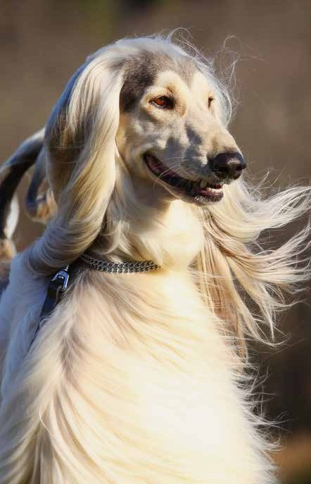

**The Afghan Hound is a tall and long-haired dog from Afghanistan. It is believed to be one of the oldest types of dogs still in existence, but wasn’t discovered by the western world until the 19th century.**

Some dogs were brought to Europe in the early 1900s, but none remained after the first World War. The breed today stems back to a group of dogs brought to Scot- land from Pakistan in 1920. The first dogs to reach the USA came over in 1926.

Afghan Hounds are known for being highly individual, aloof, and dignified. That is, unless they’re playing. They love to have fun and often show a clownish side when it’s time to play.

These dogs make wonderful family members, but they need a lot of exercise and they are very fast. They are also able to run for a long time, so you’re not likely to jog an Afghan tired.

When it comes to grooming, the long coat needs regular brushing and care.

Most Afghan Hounds weigh between 44 and 59 pounds and need a Large PlexiDor dog door.

*“We are very pleased with your product, the PlexiDor Wall Unit. The Medium size is perfect for our 21 pound terrier mix “Cashew.” We completed the installation ourselves with professional results. Thank you for making such a great product that opens doors for pets around the country!”*

6 *Paul Goodman – San Diego, California*

**Australian dog breeds have mainly developed as working dogs, helping settlers and pioneers manage cattle, control rodent and vermin popu- lations, and protect the family.**



# Australia

The Australian Cattle Dog is the most known dog breed outside its country of origin, but there are many other breeds from Australia. For example, the Australian Terrier, Australian Kelpie, Halls Heeler, Kangaroo Dog and Miniature Fox Terrier.

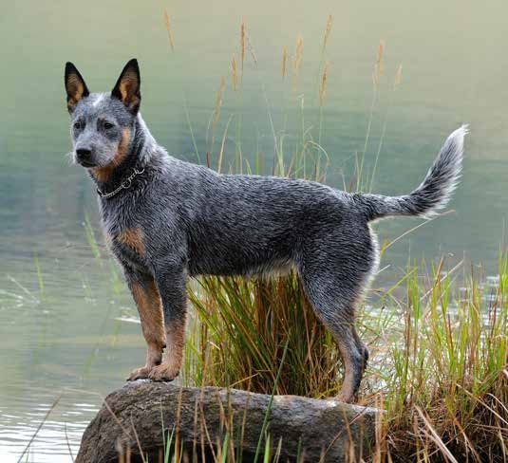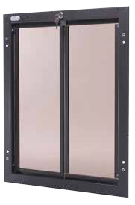

Australian Cattle Dog

**The Australian Cattle Dog is often called ACD, or just cattle dog, and these are energetic cattle herders ready to work all day. In their home land Australia these dogs drive cattle across long distances over rough terrain, and they are unfazed by angry cows. An individual with strong herding instinct can get the idea to herd anything that moves.**

Australian Cattle Dogs are agile, curious, strong, and intelligent. They consistently score amongst the ten most intelligent breeds. They generally also have a lot of energy, and paired with bright minds this means they need something to do. Bring the ACD along on adventures, jogging, hiking, or whatever the family is up to.

This is a wonderful breed for herding, obedience training, or agility, and the dog bonds closely with the family.

Little grooming is required, and an occasional bath and brushing is enough.

Most Australian Cattle Dogs weigh under 50 pounds, and need either a medium or a large PlexiDor dog door. Contact customer service if you’re uncertain of the size.

**Get a PlexiDor product catalog!**

### Visit: [www.plexidors.com](http://www.plexidors.com/) Call: 800-283-8045

**Belgium is a small country in Western Europe that shares borders with France, Germany, Luxembourg, and the Netherlands. There are quite a few Belgian dog breeds, several of which are often used as guard dogs and police dogs.**

Famous Belgian dog breeds include the Belgian Shepherd Dog that is divided into the Groenendael, Laekenois, Malinois, and Tervuren, the Bloodhound, the Bouvier des Flandres, and the Schipperke.

# Belgium

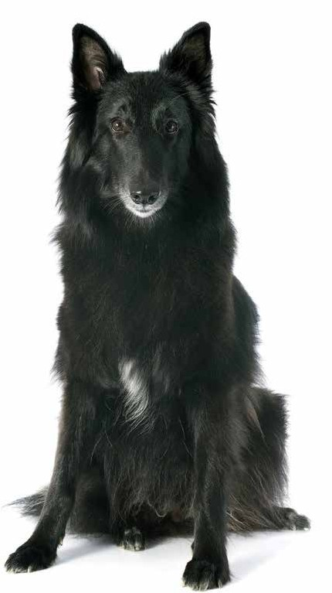

Groenendael

**The Groenendael - or Belgian Sheepdog - is a working dog from Belgium. This breed is elegant, strong, intelligent, and easy to train.**

The breed stems back to the 1800s and were originally used as herders, watchdogs, and companions. Their smarts and versatil- ity soon made them popular outside the country of origin, and early on the Groenendaels served as police dogs in Paris and New York City, and they were famous for catching smugglers for Belgian customs.

Many other breeds declined during the world wars, but the Groenendael’s usefulness allowed them to thrive. During WWI they carried messages, served as ambulance dogs, and even pulled machine guns. During WWII they guarded military instal- lations and watched for intruders.

In today’s world, not many need a herding dog, but the Groenendael still excels. Many work in search and rescue, as guide dogs, and as therapy dogs. They also do very well in dog sports such as obedience, agility, and tracking.

This is a high energy breed that likes to have a lot to do. They need exercise, but are able to relax in a home environment, and they’re known as devoted and gentle companions that do well with children.

A Groenendal typically needs a large PlexiDor pet door.

*“How I and my dogs managed before we bought a PlexiDor dog door I will never know. This is the best thing I have ever bought for my dogs, and they agree.”*

*Mr A.– Belgium*

8

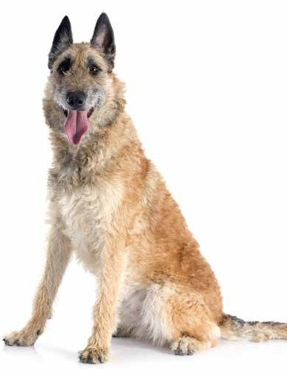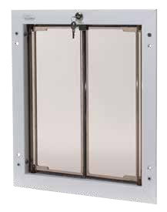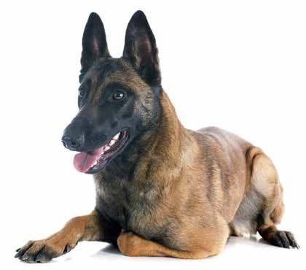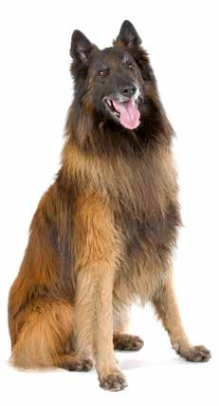

Belgian Sheepherding Dogs

**There are four types of Belgian Sheepherding dogs: the Groenendael, the Malinois, the Tervuren, and the Lakenois. They are similar in body and temperament, but differ in coat and region of origin.**

The **Malinois** is alert and filled with energy. Many mistake this breed for a German Shepherd, especially since the Malinois is often used by police and military, but it is a completely different breed.

A Malinois is intelligent, confident, and loves to work. Besides being great working dogs, they are popular in obedience trials, herding, sledding, and tracking.

The **Tervuren** is an elegant and devoted dog that often excels in obedience and agility competitions. It is an outstanding herder that also does a great job as therapy dog or guide dog.

The **Laekenois** is clever, alert, and can be quite protective of both family and property. They were developed to guard and tend to flocks. As all working dogs they require ample exercise and are happiest with a job to do.

**Learn more about pet doors!**

### Visit [www.plexidors.com](http://www.plexidors.com/)

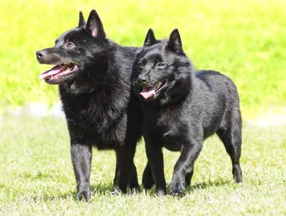Schipperke



*“The PlexiDor dog door is the greatest thing, it really is. It frees you and your dogs, and you will experience very little heat loss.”*

*Eva Kaufman – Ontario, Canada*

10

**The Schipperke is a small dog with foxlike features that originally worked as companion, watchdog, and vermin hunter. It often worked on boats - the word “schip” means boat - and the breed is nicknamed “Little Captain”.**

The Schipperke resembles a nordic breed, but it really stems from a black sheepdog called the Lauvenaar, which was bred down in size.

This is an active little dog known for being enthusiastic and joyful. They’re small dogs built for hard work and love to be included in whatever the family does.

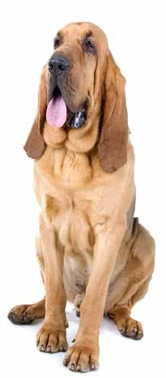Bloodhound

**The Bloodhound is an old breed, and depending on who you ask it might come from France, Belgium, England, or Scotland. We don’t know exactly how old the breed is, but it is mentioned in writings from the third century AD as a dog unrivaled for scenting power and determination.**

The ancestors to the Bloodhound are believed to stem from the Mediterranean countries, and came to western Europe from Constantinople. At the time there were two strains; black or white. The black dogs were known as the Chien de Saint-Hubert and were bred by monks at the Saint-Hubert Monestary in Belgium. The white dogs became known as Southern Hounds. The breed reached its modern form in England.

Bloodhounds are tireless workers for law enforcement, and they are so good at tracking a scent their work has been accepted in courts of law. They can detect a scent trail left several days ago, and the average bloodhound has around four billion olfactory receptor cells. The average human has around five million.

These dogs are affectionate but often shy and sensitive. They enjoy company, both from other dogs and humans, and they’re known for being easygoing. They require regular brushing, and all the wrinkles must be kept clean.

A Bloodhound can weigh up to 110 pounds, and will require a large or extra large PlexiDor dog door depending on the individual.

Bouvier des Flandres

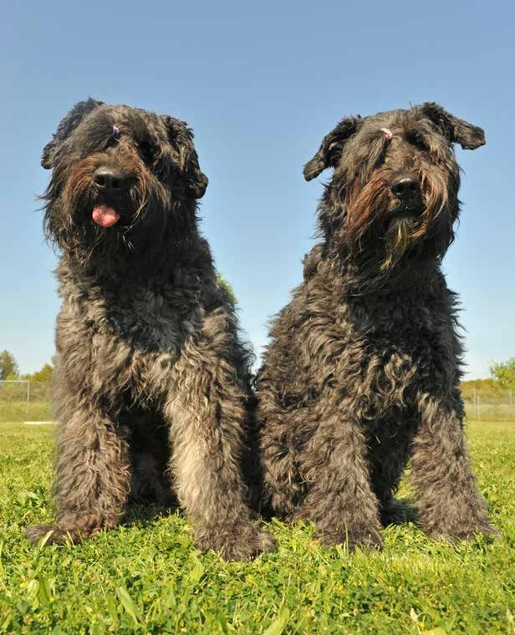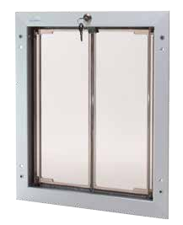

**The Bouvier des Flandres is an agile and even-tempered herding dog created by farmers and cattle merchants that needed help with their work.**

The breed originated in Flanders - a region that encompasses the northwestern part of Belgium and adjacent parts of the Nether- lands and France.

Today Flanders refers to the Dutch speaking northern portion of Belgium, but as far as dog breeds go the Bouvier could just as well be considered a Dutch dog.

Early individuals didn’t look much alike, and sizes and colors varied. They had enough in common to be called Bouviers, but it took

a while before the breed reached a con- form look, and the different types got funny

nicknames, like Vuilbaard which means “Dirty Beard.”

Bouviers were very popular up until World War I, but the war devastated the areas where the dogs were bred and most of the dogs were abandoned as their families died or fled. Only a few families managed to stay and keep their dogs until the war was over.

These dogs are known for being steady, resolute, and fearless. They make great family members and guardians that also excel at herding, obedience, agility, and tracking.

While the dogs are fairly calm indoors, this is a large working breed and they need lots of exercise and something to do.

A Bouvier des Flandres typically weighs between 80 and 120 pounds.

**Get a PlexiDor product catalog!**

### Visit: [www.plexidors.com](http://www.plexidors.com/) Call: 800-283-8045

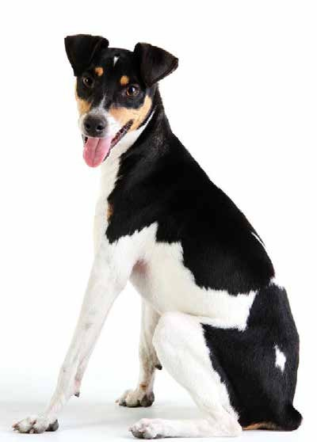

**As big a country as Brazil is you might think there would be many dog breeds native to the country, but there are only a handful. The Fila Brasileiro is one of the most well known.**



Brazil

These dogs are completely dedicated to their main handler and family, and extraordinarily patient with children and pets that belong to the family. They make great trackers, hunters, and hurders, and the Brazilian army has used them for work in the jungle. Through the breed’s history, the Fila Brasileiro has been used for everything from guarding gold mines to hunting jaguars.

Other dog breeds from Brazil include the Brazilian Dogo, also called the Brazilian Bull Boxer. These dogs are quite rare with around 2,000 dogs registered world wide.

The Rastreador Brasileiro was made virtually extinct from an outbreak of disease compounded by an overdose of insecti- cide. Ever since, efforts have been made to recreate the breed, but this is very difficult since there are so few dogs left of the right type.

Brazilian Terrier

**The Brazilian Terrier is rare outside of Brazil, but one of the most pop- ular in its homeland. The breed stems back to the 1800s when Jack Russell Terriers arrived to Brazil from Europe. They were bred with Min- iature Pinschers, Chihuahuas, and possible other small dog breeds. This resulted in an alert and energetic dog.**

These dogs are known for being intelligent and alert with an abundance of energy, and they love to play, bark, dig, bark, romp around, bark, and dig some more. Given the chance, they also enjoy chasing small animals. They were originally used for vermin control and have developed a unique form of teamwork where they surround their prey.

Taking their high energy level and intelligence into account, this is a breed that requires both mental and physical activity. If you want a companion that is up for hiking, running, power walking, playing, and still has strength left to chase the cat in the middle of the night, this might be a perfect choice.

Brazilian Terriers are generally healthy and often live up to 15 years. They are considered easy to train, but owners should be aware of their high energy level.

*“The PlexiDors are fantastic and I don’t know what I’d do without it. I have King Shepherds which hover between 110 and 140 pounds, and they love the freedom of going in and out.”*

*Elaine Perry– Delaware*

12

# Canada

**Canada is the home of several well known dog breeds, such as the Labrador Retriever which is the most popular dog in many countries around the world.**

Other popular breeds from Canada include the Newfoundland, Nova Scotia Duck Tolling Retriever, and Seppala Siberian Sleddog. They have one thing in common: they are hard workers.

A number of Canadian breeds are sadly extinct today, such as the Hare Indian Dog, Salish Wool Dog, and the St. John’s Water Dog.

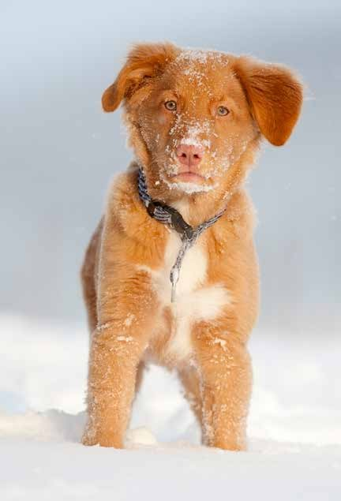

Nova Scotia Duck Tolling Retriever

**The Nova Scotia Duck Tolling Retriever - or Toller - is an athletic and intelligent Canadian dog breed with an abundance of energy. If you want to do some- thing, the Toller is ready for action.**

The dogs are believed to stem from a cross of Golden Retrievers, Chesapeake Bay Retrievers, Labradors, Flat Coated Retrievers, and farm Collies. There might be a sprinkle of Irish Setter and Cocker Spaniel in there too.

Tollers were originally used for retrieving from icy waters, and they have webbed feet along with a water repellent outer coat. Like most working dogs they need both physical and mental stimulation to stay happy and healthy.

If you’re interested in dog sports, the Toller will be right there by your side. They generally do great in agility, dock diving, and obedience. Many also work in search and rescue. The combination of intelligence, working drive, great sense of smell, and manageable size make them ideal for the job.

Tollers require little grooming. An occasional brushing and bath will be enough.

A Toller weighs between 37 and 51 pounds, and a Large PlexiDor dog door is a perfect companion.

**Get a PlexiDor product catalog!**

### Visit: [www.plexidors.com](http://www.plexidors.com/) Call: 800-283-8045

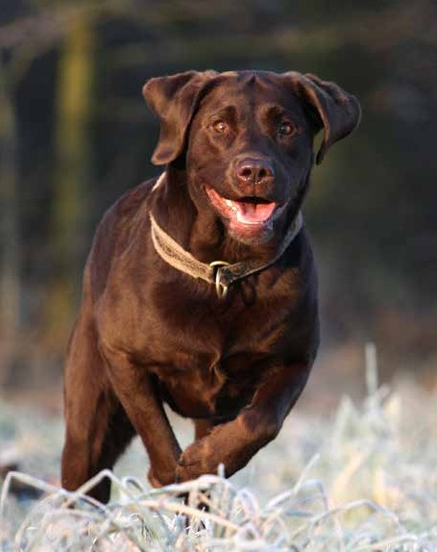Labrador Retriever

**The Labrador Retriever is the most popular breed of dog not only in its originating country of Canada, but also in the United States and the United Kingdom. It is also the most popular choice for assistance dogs in a number of coun- tries. Many work as guide dogs for the blind, or as police dogs.**

The breed originated in Newfoundland, where they were used to work with fishermen; the dogs helped pull in nets and caught fish that escaped from fishing lines. Since then, the dogs have been crossed with Setters, Spaniels, and other retrievers, and the breed has become an ideal family dog.

Labradors typically love to swim and frolic in water, and they have webbed paws. Many are athletic and energetic, and love playing catch- and-retrieve games. They are normally cheerful, get along well with children, and like other pets.

There are three colors of Labradors: yellow, black, or chocolate, and they normally weigh between 55 and 75 pounds. If you want a dog door for your Labrador, a PlexiDor large is a perfect match.

Landseer

**The Landseer is a Canadian breed named after a British painter. Sir Edwin Henry Landseer painted “A Distin- guished Member of the Humane Society” featuring a Landseer in the 1830s. Some kennel clubs consider this a black and white version of the Newfoundland, but many recognize it as a separate breed.**

Landseers are sweet, gentle, and serene. The average member of the breed loves to swim.

There are two types: The Landseer Newfoundland and the Landseer European Continental Type. They share the sweet disposition and love of water, but the European version is tall- er, has shorter hair, and lack underwool. They also have very long legs and are both fast and tireless runners.

The Newfoundland version excels at rescuing drowning peo- ple and often work with fishermen, hauling heavy nets to the shore.



*“Thank you. Thank you. Thank you. My five retrievers can now choose when to go out for themselves and I don’t have to keep getting up to open the door.”*

*Mrs. L – Surrey*

14

Newfoundland

**The Newfoundland is a Canadian dog breed known for their giant size, calm disposition, loyalty, and strength. The breed was created to work side by side with fishermen, and these gentle giants excel at water rescue. They are strong enough to navigate powerful tides and swim through rough ocean waves, and they can swim long distances while also being large enough to bring drowning people ashore.**

Through history, these dogs have performed many tasks. Besides working with fishermen they’ve hauled wood and powered black- smith bellows.

Newfoundlands are loyal and make wonderful family dogs. They are sweet, loving, easy to train, and generally good with children. However, their mere size can create problems if they’re not trained. The largest known Newfoundland weighed 260 pounds and mea- sured over 6 feet from nose to tail.

This is a breed that requires daily exercise to stay healthy. They also need regular brushing.

*Newfoundland*

*Landseer*

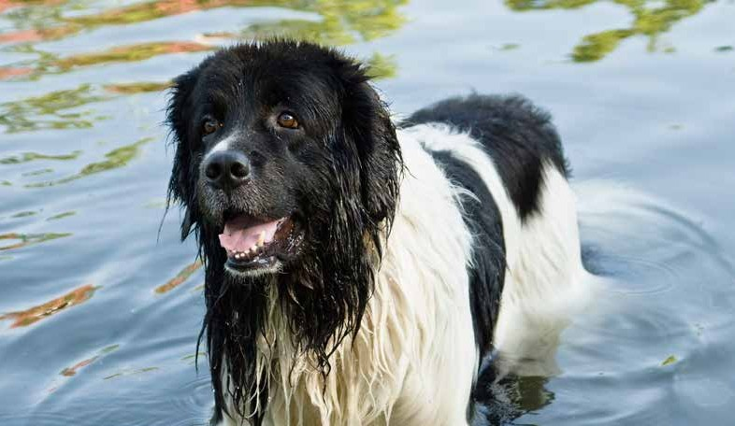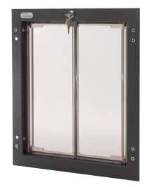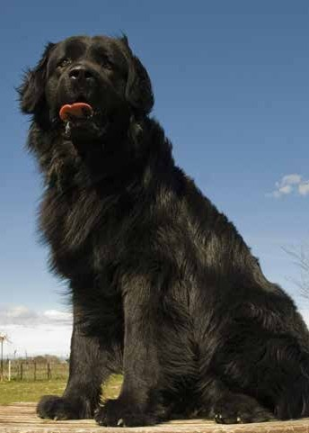

**Learn more about pet doors!**

### Visit [www.plexidors.com](http://www.plexidors.com/)

**Quite a few dog breeds stem from China, and the breeds from this area have often been created for other reasons than European or American dogs. Many Chinese breeds are small, and while some were hunters, others were companions for royalty.**

Chinese dog breeds include the Shar Pei, Chinese Crested, Chow Chow, Japanese Chin, Chinese Chongqing Dog, Pekingese, Pug, Xiasi Dog, and the Kunming Wolfdog.

# China



16

*“We are in rescue, and the PlexiDor dog door is used many times throughout the day by 15 dogs. The largest dog is under under 100 lbs, and the smallest about 8.5 soaking wet. I have never found a pet door that will take the abuse the PlexiDor does. I am so pleased with this product. It is worth every penny..”*

*J. Ochs– Pennsylvania*

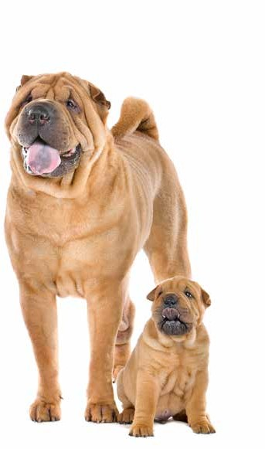Shar-Pei

**The Shar-Pei is a wrinkly dog with triangular ears and a blue-black tongue. There are only two breeds in the world with blue tongues: the Shar-Pei and the Chow-Chow. Both these breeds stem from China.**

The origins of the Shar-Pei are unknown, but there are images on pottery in China from the Han Dynasty (206 BC) with strong resem- blances to the breed. The breed was originally kept as diverse farm dogs in the countryside, used for hunting, herding, and guarding. The dogs were bred for intelligence and strength. The unusual skin and coat stems back to this time too; the loose skin and prickly coat helped the dogs fend off wild animals.

The Shar-Pei is known for being calm, independent, and loyal. These dogs are devoted to their family, but can be reserved amongst strangers.

Puppies have many wrinkles, but the dogs “grow into” their skin as they mature, and adults generally only have wrinkles on the face, a few on their shoulders, and some at the base of the tail. The wrinkles need some extra care, make sure to keep the skin clean and dry.

An average Shar-Pei weighs up to 64 pounds and requires a Large PlexiDor dog door.

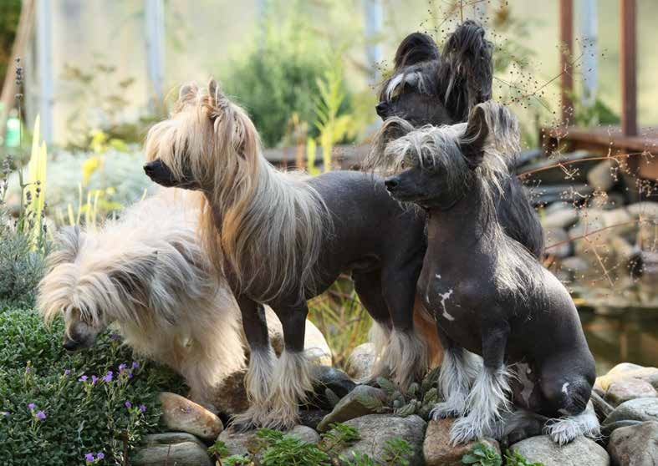

Chinese Crested

**The Chinese Crested is an alert, charming, and affectionate breed believed to have accompanied Chinese sailors all over the world. They first appear in written history around the 1500s, and even then explorers encountered them in Central and South America as well as Africa and Asia.**

This breed is believed to be an evolution of African hairless dogs, bred down in size by the Chinese. They are the most pop- ular of the hairless breeds, but still considered rare. Most are hairless, but there is a variety with a double, straight, and soft coat called a Powderpuff. The two types can be seen in the same litter, but the Powderpuff is genetically recessive and will disappear with time.

Chinese Crested are clever and good at learning tricks. They covet company and need to be a part of the family.

**Get a PlexiDor product catalog!**

### Visit: [www.plexidors.com](http://www.plexidors.com/) Call: 800-283-8045

Pekingese

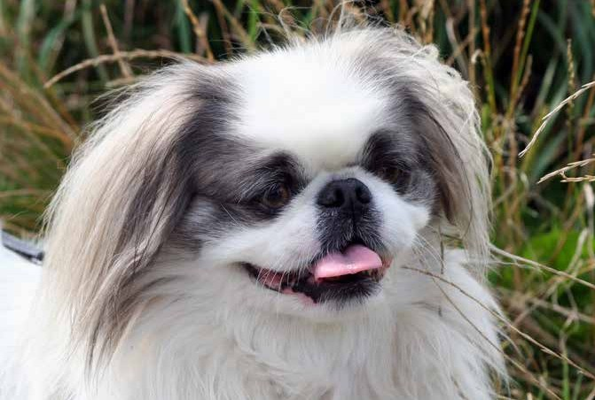

**The Pekingese is an ancient breed originally created to resemble stylized Chinese lions. These dogs have changed little during the ages, and the dogs of today look a lot like the originals. In ancient China, stealing a Pekingese was punishable by death, and there were long periods of time when common people weren’t allowed to own the dogs. If someone crossed paths with a Pekingese they were supposed to bow and show respect.**

These dogs are known for being good natured, affectionate, and intelligent. They enjoy going for a walks and accom- panying their family on adventures, but do not require extensive exercise. They do need regular grooming. If the coat is held long, the dog must be brushed thoroughly once a week. Many have the coat cut to make it more manageable.

These cheerful little dogs have an average lifespan of 12 years and are fairly healthy. Just be aware that the short nose means they can’t handle heat well, and they are prone to heatstrokes.

A Pekingese usually weighs between 7 and 14 pounds. A small individual can get by with a small PlexiDor dog door, but most need a medium PlexiDor dog door.

*“Thank you! I have loved my PlexiDor dog door for 15 years! Thank you for such a good product!”*

*P. Jennings – North Carolina*

18

Chow Chow

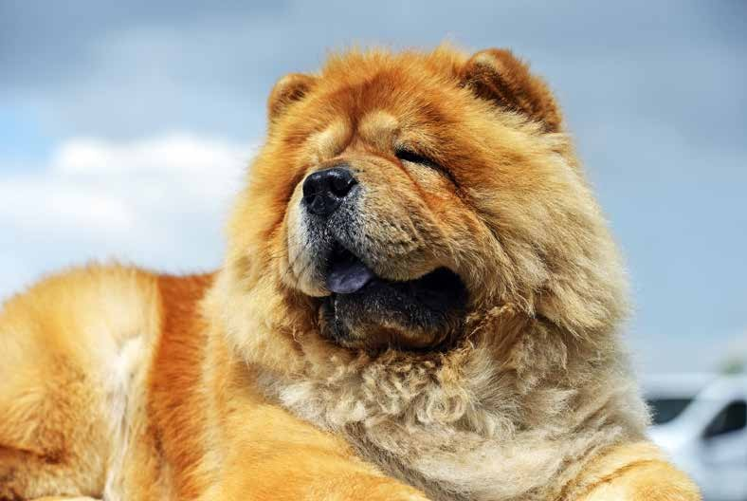

**The Chow Chow comes from Asia and has been traced back to China’s Han dynasty, over 2,000 years ago, and it is considered one of the oldest recognizable breeds. It is also believed to be the model for the “Foo dogs” - the traditional stone statues that guard Buddhist temples.**

Many recognize the Chow Chow because of its blue tongue - a trait it only shares with the Shar-Pei. No other dog breeds have blue tongues. This is a sturdy dog with a dense double coat. Chow Chows are generally serious, dignified, and intelligent. While devoted to family members, they are often uninterested in strangers.

These dogs are adaptable and do well in all sorts of living arrangements. They don’t need extensive exercise, and with regular walks they can do very well living in apartments. They are also a healthy breed, but they do require regular grooming. Many Chow Chow owners spend a couple of hours each week brushing their dog.

Depending on gender, a typical Chow Chow weighs somewhere between 45 and 70 pounds, and requires a large PlexiDor dog door.

**Get a PlexiDor product catalog!**

### Visit: [www.plexidors.com](http://www.plexidors.com/) Call: 800-283-8045

Pug



*“The PlexiDor dog door is the greatest thing, it really is. It frees you and your dogs, and you will experience very little heat loss.”*

*Eva Kaufman – Ontario, Canada*

20

**The Pug is one of the oldest dog breeds, and has flourished since at least 400 BC. The earliest mentions of the breed come from China, where this sturdy and cheerful little dog was a pet of the Buddhist monasteries in Tibet.**

This is a lot of dog in a small package. Pugs are even-tempered, loving, charming, and often filled with mischief. They are curious and love to explore, but don’t need excessive amounts of exercise. A Pug can thrive almost anywhere - as long as they’re close to the family. For a Pug, the family is the sole reason for living.

Pugs are generally happy. They’re happy living in the country or in the city, amongst children or with the elderly, amongst other pets or as an only dog. The average Pug doesn’t care where he or she lives, as long as there is love.

The short coat doesn’t need a lot of grooming, but they shed a little. The wrinkles on the forehead and face must be kept clean and dry. Like all breeds with short snouts, the Pug overheats quickly and can be prone to heatstrokes.

A Pug generally weighs between 14 and a18 pounds and needs a medium PlexiDor dog door.

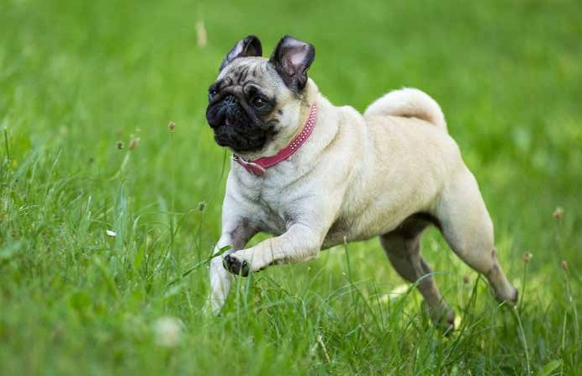

# Croatia

**Croatia is the home of several dog breeds, and the most famous is without a doubt the Dal- matian whose spotted appearance has gained worldwide fame and poluarity.**

Other breeds from the region include the agile and adaptable Croatian Sheepdog, various hunt- ing dogs, and the Tornjak - a mountain sheep dog known for its calm disposition, self-confidence, and seriousness. The first written mentions of the Tornjak date back to the 9th century

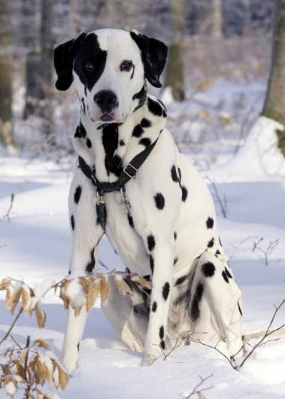

Dalmatian

**The Dalmatian is the only spotted dog breed. Its true origins are veiled in mists of time, and these dogs have been credited with many nationalities and names. The spotted dog we know today has gotten its name from Dalmatia - a historical region of Croatia close to the Adriatic sea - but dogs of this type have appeared all over Europe, Asia, and Africa. Many believe that the breed originated in India, and**

**there are dogs looking like Dalmatians on Egyptian tombs and in ancient ruins as old as 5,000 years.**

Dalmatians have had many purposes through history. Some have been used for hunting, some as dogs of war or border guardians, and others worked as shepherds. Many dogs can do these things, but Dalmatians have a unique trait: no other breed share their talent for running with horses.

Most Dalmatians will fall in behind a horse and cart, or trot beside the shoulder of a horse even if they’ve never seen one before. This probably created the breed’s original association with firemen; it was natural for the dogs to follow horse-drawn fire engines.

These dogs are energetic and require daily exercise and train- ing. They learn quickly and have excellent memories, and excel at obedience, agility, and other dog sports. Their endurance also makes them great search-and-rescue dogs. If you’re con- sidering a Dalmatian, remember their past as coach dogs; they require a lot of exercise and something to occupy them.

Dalmatian puppies are born white, and their first spots appear around three weeks after birth. After a month they have most of their spots, but new ones can appear throughout life.

**Learn more about pet doors!**

### Visit [www.plexidors.com](http://www.plexidors.com/)

**The Havanese is the most known dog breed from Cuba, and the Havana Silk Dog is a variation of the breed where breeders have attempted to recreate older depictions of the breed. The Havana Silk Dog has longer legs, straighter forelegs, a silker coat, and smaller ears than the Havanese.**

In the past, the island was also home to the Dogo Cubano, or Cuban Mastiff. This large and strong breed is considered extinct since the end of the 19th century. Descendants of the breed still exist, but have been cross bred with Dogo Argentinos and American Pit Bull Terriers.

# Cuba



*“I’ve had one of your extra-large PlexiDors for several years and I love it. After having had several other cheaper doors, this door is absolutely worth every penny.”*

*Lewis Mills– Jefferson City, Missouri*

22

Havanese

**The Havanese is the national dog of Cuba, and its ancestors arrived to the island from Tenerife in the early 16th cen- tury. At the time Cuban trade was highly restricted by the Spanish, and Tenerife was one of the few open ports. The breed has an interesting history even today; every dog that lives outside of Cuba stems from 11 dogs that fled with their owners at the time of revolution.**

This is a small and sturdy breed. Their coat looks warm, but it has developed to insulate and protect the dogs from tropical sun. They require regular grooming, but do not shed.

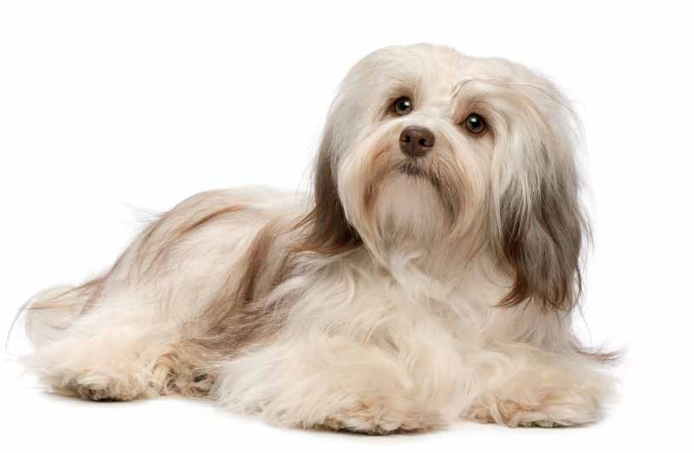Havanese are friendly and become very attached to their families. They are known for being affectionate, intelligent, playful, and easy to train. This is a quiet breed too; many Havanese never bark, and they get along well with dogs, cats, and other pets.

A Havanese generally weighs between seven and thirteen pounds, and does well with a medium PlexiDor dog door.

# Denmark

**In the past, the border between Denmark and Sweden changed from time to time, and there is some dispute as to which country certain dog breeds really belong to.**

There are three dog breeds mainly associated with Denmark: Broholmer, Danish Swedish Farmdog, and Old Danish Pointer.

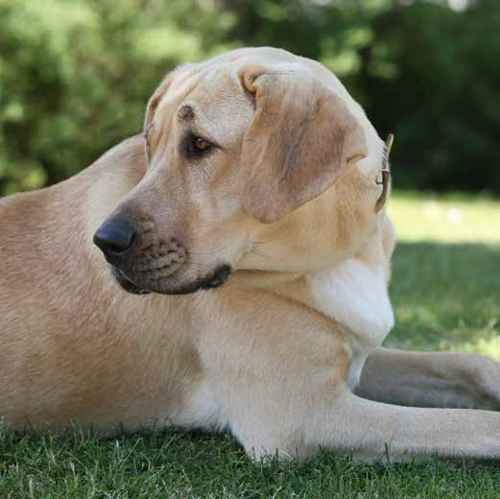

The Great Dane is not a Danish dog despite the name - this breed comes from Germany.

Broholmer

**The Broholmer is also called Danish Mastiff. This is a very large Danish dog breed with a loud and impressive bark.**

The breed originally comes from a cross between English Mastiffs and various German dogs, and the name stems from Sehested of Broholm who was an 18th century game keeper.

The Broholmer was nearly extinct after the second world war, but isolated individuals were found and Danish enthusiasts saved the breed.

Broholmer dogs are known for having good self confidence and being calm, friendly, and good tempered.

These dogs have an average life span of 7-12 years. Females weigh between 90 to

130 pounds and males 110 to 150 pounds, and they require an extra large PlexiDor dog door.

**Get a PlexiDor product catalog!**

### Visit: [www.plexidors.com](http://www.plexidors.com/) Call: 800-283-8045

**Ancient Egypt might be most closely associated with cats, but dogs were also important, and the Egyptian ancestry can be seen in many modern dog breeds.**



Egypt

Dogs were held in high esteem, and one of the earliest doc- umented domesticated animals whose name we know came from Egypt. He was balled Abutiu and lived before 2280 BC. He is believed to have been a royal guard dog.

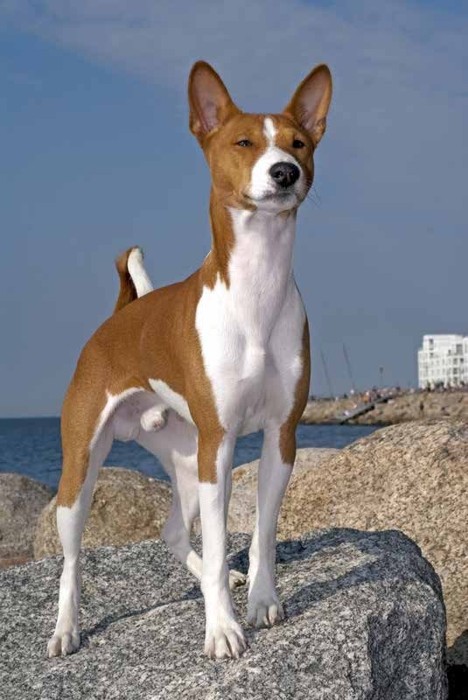Some dog breeds with roots in Egypt include the Ibizan Hound, Basenji, Saluki, and the Pharaoh Hound.

Basenji

**The Basenji is an elegant hunting dog with roots in Africa, and can be traced back to the Pharaohs of ancient Egypt. They are also known as “the barkless” dog. Instead of barking, they yodel when excited.**

Basenjis are independent, and known for thinking and making decisions on their own. While extremely intel- ligent, they can be difficult to train, because they need to see the point in whatever they’re asked to do.

An average Basenji is alert, curious, and energetic. They are also athletic and love to climb.

This breed has some habits unusual for dogs. They don’t like wet weather, they clean themselves all over like a cat, and they don’t get the “doggy smell.”

The Basenji tends to become emotionally attached to one person. They accept other family members and are generally loving and patient with children, but there’s one person that is “theirs.”

An average Basenji weighs around 24 lbs, and a Medi- um PlexiDor dog door is the perfect size.



24

*“My wife and I own three Leonbergers and three Chinooks. We were constantly replacing flaps or panels. Then we installed two PlexiDor XL units at our new home. They have functioned flawlessly and allow our pets 24 hour access to their yard. We are very satisfied that we invested in a superior product.”*

*Rick Skoglund – Waldoboro, Maine*

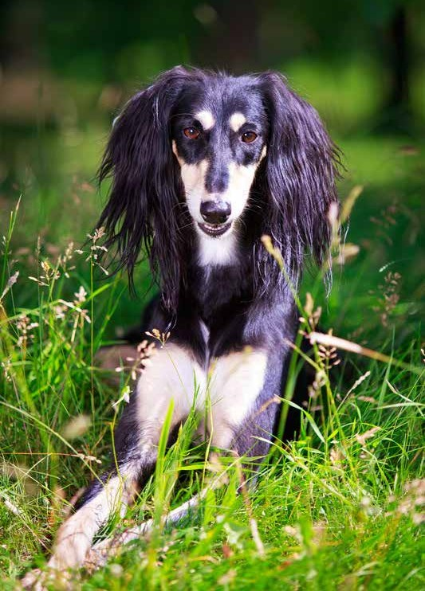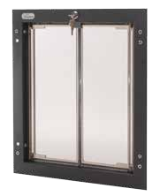

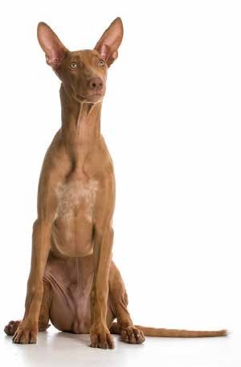Pharaoh Hound

**The Egyptian Pharaoh Hound was traditionally used as a companion for hunters from Malta. Some scientists say there is no DNA evidence for the breed being related to Egyptian dogs, others claim the breed is related to ancient Egyptian dogs with a lineage back to 3,000 BC.**

Pharaoh Hounds are graceful, powerful, and fast. They make pleasant companions who can be peaceful indoors yet loves to play given an opportunity.

This breed has a unique ability - they blush when excited. The nose and ears get a rosy hue.

Pharaoh Hounds are generally healthy and need little grooming. As their coat is short and thin they need to live indoors with soft bedding and warmth.

Saluki

**The Saluki looks graceful and fragile, but don’t be fooled by appearances - this is a marathon runner with great strength and endurance. They run at the speed of Greyhounds and can keep the pace over distance.**

This is the royal dog of Egypt, and the Saluki is believed to be the oldest breed of domesticated dog. They are independent, gentle, and loyal, but they work alone. No one can keep up with a Saluki! They are so fast they’ve been used to hunt Gazelles - the fastest of Antelopes.

They even have padded feet to minimize the impact of excessive running.

Their hunting instinct is deeply rooted, and the dogs will give chase if something runs. When it comes to groom- ing, they require weekly brushing and an occasional bath.

**Get a PlexiDor product catalog!**

### Visit: [www.plexidors.com](http://www.plexidors.com/) Call: 800-283-8045

**Quite a few dog breeds stem from Finland. Many are nordic type dogs, but not all. Breeds from Finland include the Finnish Hound, Finnish Lap- phund, Finnish Spitz, and Karelian Bear Dog.**

Other breeds from Finland include the Laika, Lap- ponian Herder and Lapponian Shepherd, the Seskar Seal Dog that was extinct and recently recreated, and the Tamaskan Dog.

# Finland

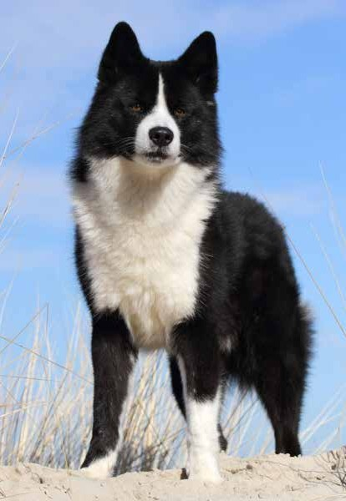

Karelian Bear

**The Karelian Bear is a tenacious hunter with fearless nature and quick reflexes. They have an instinct for moving and handling bears safely, and are sometimes used for non lethal bear control.**

The breed is also called Karelsk Björnhund, or its Finnish name Kerjalankarhukoira. In its homeland, the Karelian Bear is primarily used as a hunting dog, but it is also a good breed for search and rescue, and many excel in obedience trials.

This is a dog breed that prefers to be outside, and they need plenty of space to move. They are intelligent and independent, which also means they get bored easily and need mental stimulation as well as physical.

The average Karelian Bear loves people and children to the point where they’re prone to separation anxiety. They are social and want to be with their family to the point where they can be anxious if left alone.

The breed isn’t common in the USA, but the Washington department of fish and wildlife employs a few, utilizing their instinctive abilities for handling bears in a safe manner.

*“Your company has outstanding customer service and friendly, knowledgable staff. I just wanted to write to you and tell you how much I love your doors and how happy they make both me and my best friends.”*

*Merry LoCurto*

26

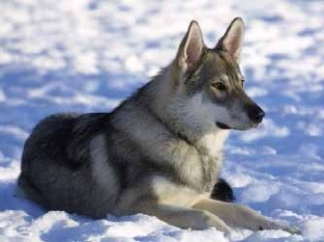

**The Tamaskan Dog is a sleddog type dog bred for versatility. These dogs excel at agility, obedience, and working trials. They are also good at pulling sleds.**

The Tamaskan Dog has been bred to resemble wolves, but they are dogs. An average Tamaskan Dog weighs

between 55 and 88 pounds, and the breed is generally healthy.

**Learn more about pet doors!**

**Visit** [**www.plexidors.com**](http://www.plexidors.com/)

Finnish Spitz

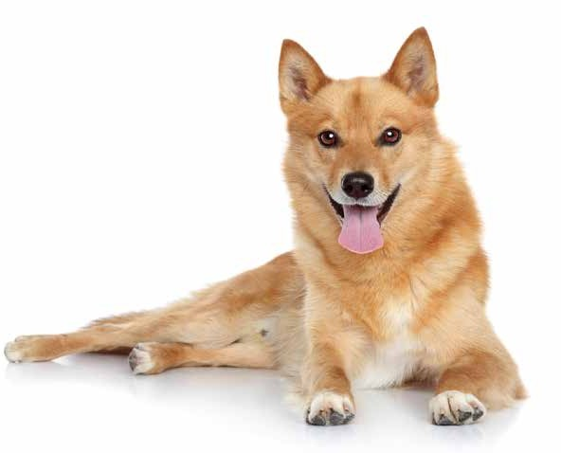**The Finnish Spitz is an intelligent, lively, and friendly dog from Finland that loves spending time with the family and being active. They get along well with other dogs and are known for loving children.**

This is a hunting breed originally created for hunting birds and small game, but they are often used for hunting moose and even bears. Being a barking hunting dog, they tend to bark at anything out of the ordinary, and a Finnish Spitz can bark up to 160 times a minute. There are even barking comptetitions in Finland!

A Finnish Spitz is generally a healthy dog, and they have an average life span of 11-14 years. Females weigh between 18 and 22 pounds and males between 26 and 28 pounds, and the medium PlexiDor dog door is a perfect match.

Tamaskan Dog

**Many dog breeds come from France, some well known over the world and others more local.**

**There is a great variation in dog size and purpose, from the small Papillon to large working dogs.**

Breeds from France include the Picardy Spaniel, Wirehaired Pointing Griffon, Briard, French Spaniel, French Bulldog, Grand Basset Griffon Vendéen, Pyrenean Shepherd, and many more.

# France



28

*“I installed my kitty door in a basement window this summer. The cat finds it easy to use. It is now*

*-10 with wind chill days and my basement stays nice and warm. No cold air comes through the cat door. Your pet door is a great product!”*

*Val Maloney – Milford, CT*

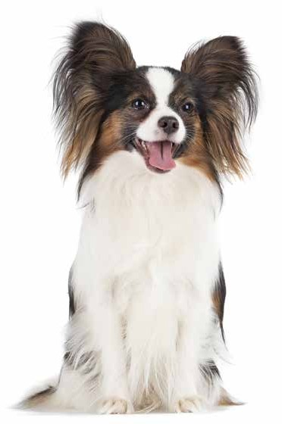Papillon

**Papillon is the French word for butterfly, and the breed gets this name from the long hair on the ears that resem- ble butterfly wings. Some Papillons have drooped ears, and they are called Phalène, which means moth.**

The Papillon is a type of Spaniel, and this breed is one of the oldest toy spaniels, stemming back to around the year 1500.

These dogs are energetic, clever, and self-assured, and they learn new things easily. This is an active dog breed and they’re happiest when they have something to do. Many do very well in agility or other dog sports. There are individuals who like to nap with their owner, of course, but the typical Papillon would much rather be running around with a toy than sitting still.

Papillons tend to be reserved around new people, and just as with all dog breeds, it’s a good idea to socialize them well from a young age.

Grooming is fairly easy, because Papillons don’t have an undercoat. They should be brushed regularly and have a bath every now and then, but other than that they require little grooming.

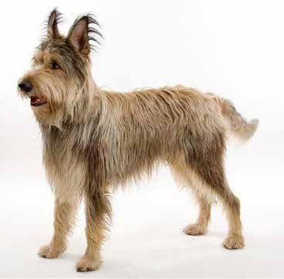Berger Picard

**The Berger Picard is a French working dog with roots back to the ninth century. The breed was used for herding - and for smuggling contraband across the border between France and Belgium.**

Berger Picards are known to be loyal, quiet, and athletic, but they crave attention, daily exercise, and mental stimulation. They enjoy swimming, running, and long walks.

Beauceron

**The Beauceron is an old French herding dog used for working sheep and cattle, first men- tioned in a manuscript from 1578. They are still the preferred breed of herding dog in parts of the country.**

Like most herding breeds, the Beauceron has a lot of energy and needs something to do. They are eager to learn and easy to train, loving, loyal, and protective of their families. This breed often excels at obedience training and police work, and they are known for being highly intelligent and brave.

The Beauceron is a large dog, weighing up to 100 pounds, and requires a large PlexiDor dog door.

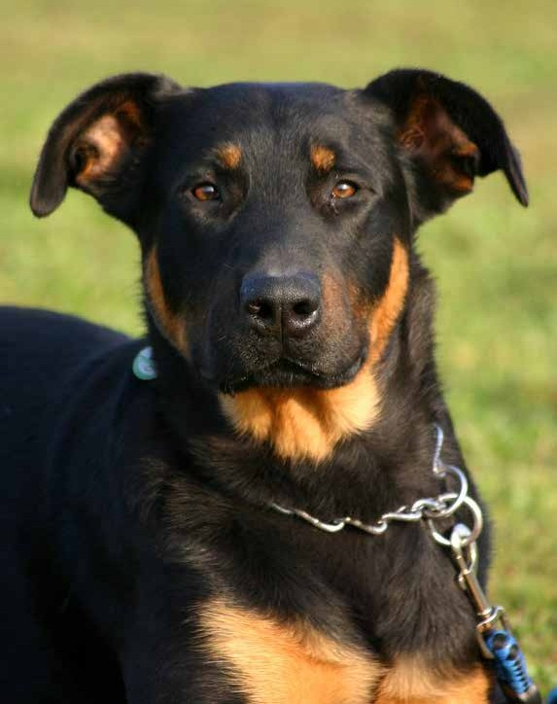

**Get a PlexiDor product catalog!**

### Visit: [www.plexidors.com](http://www.plexidors.com/) Call: 800-283-8045

Pyrenean Shepherd



*“I’ve had my PlexiDor since 2000 and it is super tough. My 85 pound weimaraners blast through the door with mammoth bones and still not a single scratch on the door panels.”*

*Cassandra Tynes – Gulfport, MS*

30

**The Berger des Pyrénées – Pyrenean Shepherd – has worked with sheep herding in southern France since medieval times. It is mentioned in medieval manuscripts, and often referred to as the “constant companion” due to its loyalty and tendency to stay by the shepherd’s side through thin and thick.**

Pyrenean Shepherds were traditionally paired with a Great Pyrenees that would protect the herd against wild animals. Two

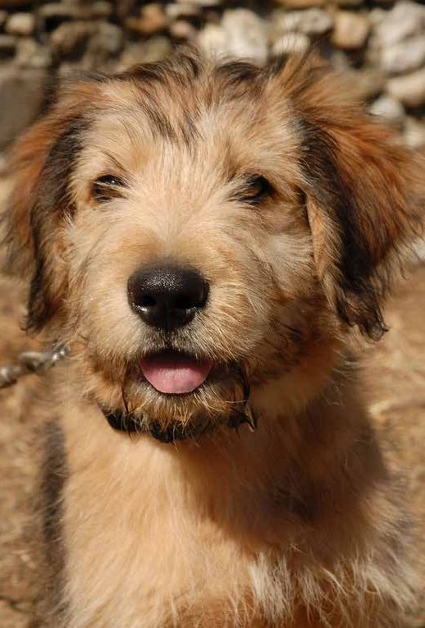Pyrenean Shepherds are enough to manage a flock of 1,000 sheep.

The breed comes in two varieties; smooth-faced and rough-faced. They are intelligent and energetic, and need a job to do. When herding, a dog easily covers 25 miles every day, and running one tired is almost impossible. Mental stimulation can make them tired, and they are great at agility, flyball, and competitive obedience.

This is not a breed that does well being left alone. They prefer to be by their human’s side at all times, and love to follow a person around the house to help with daily chores. They are very sensitive to a person’s moods and often seem to read minds. The dogs are often referred to as enthusiastic, affectionate, and active.

Pyrenean Shepherds are generally healthy dogs, and they require little grooming. An occasional bath and a thorough brushing every few weeks goes a long way towards keeping their good looks.

A Pyrenean Shepherd is small for being a herding breed; they usually weight between 15 and 32 lbs, and do well with a medium PlexiDor dog door.

Poodle

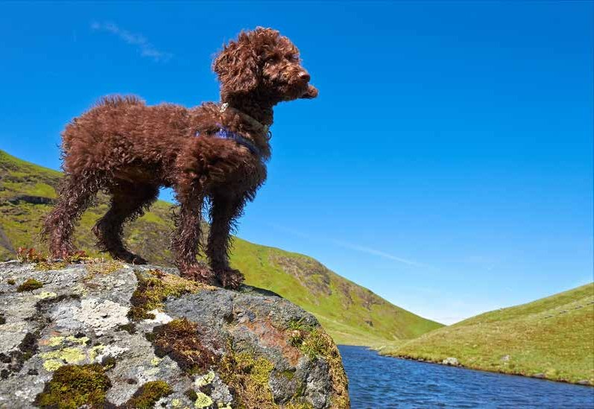

**The Poodle is an exceptionally smart dog breed that often competes with the Border Collie for top position in lists of dog intelligence. This friendly breed sheds next to nothing, comes in three sizes, and welcomes all sorts of activities.**

Poodles are the national dogs of France, but the breed is actually believed to come from Germany originally. The standard poodle is the oldest version that was bred down to Miniature and Toy sizes. The words “standard,”“miniature,” and “toy” are only used to describe the size - all Poodles are one breed.

These dogs were originally water retrievers, and the traditional haircut was designed to help the dogs swim more efficiently. The patches of hair were intended to protect vital organs and joints. There are many different ways to trim the Poodles’ hair.

Poodles are active dogs and need exercise to stay happy. They do great in many dog sports, as service dogs, and even as circus performers.

**Get a PlexiDor product catalog!**

### Visit: [www.plexidors.com](http://www.plexidors.com/) Call: 800-283-8045

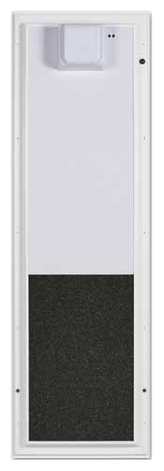**PlexiDor**® **Electronic**

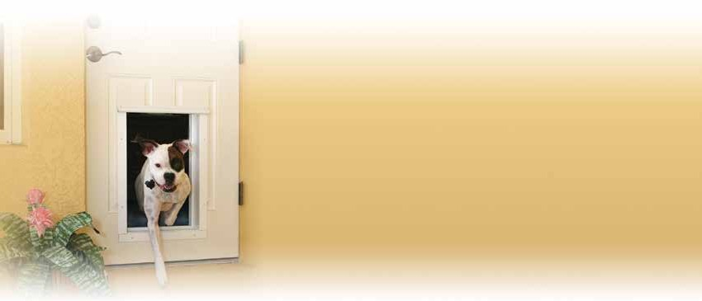

#### The ultimate in security and convenience

**Whenever security and pet access control are priorities, the PlexiDor® Electronic door is the preferred choice of pet owners worldwide.**

The door has a composite panel that slides up and down like a miniature garage door. When inactive, the panel acts as a security door.

Using state-of-the-art RFID technology, the sensor reads the pre-pro- grammed code to automatically open and close only for pets equipped with a programmed collar key. Other animals have to stay outside!

The collar key is waterproof and weighs only 0.4 ounces. It snaps onto the pet’s collar. The door can be adjusted to control how long the panel stays open. The PlexiDor® electronic plugs into a standard household power outlet or can be hardwired. It is easy to program and even easier to use.

This door accomodates dogs up to 125 pounds and all cats. Visit [www.plexidors.com](http://www.plexidors.com/) or call 800-249-8045!

##### *Secure and dependable*

##### *Durable and easy to use*

##### *Energy/money saver*

##### *Door stops everything but your pet*

**How it works:** The PlexiDor® Electronic reads the collar key’s code and opens only for your pet. The panel unlocks when the key is within range, and slides up like a miniature garage door. If the door attempts to close when there’s something in the way, it will open again and sound an alarm. Your pet will not get stuck in the door!

PlexiDor® Electronic Pet Doors are covered by a five year limited warranty. Any defective part will be repaired or replaced without expense to the customer, including standard shipping charges, for five years from the purchase date. Local labor is not covered.

*“I installed your PlexiDor 12 years ago. I have four dogs that have access to the door 24 hours a day. Needless to say, it has been used jillions of times and I have not had one problem. Thanks for a great product!”*

*Debra Rickman – Greenbrier, AR*

32

Barbet

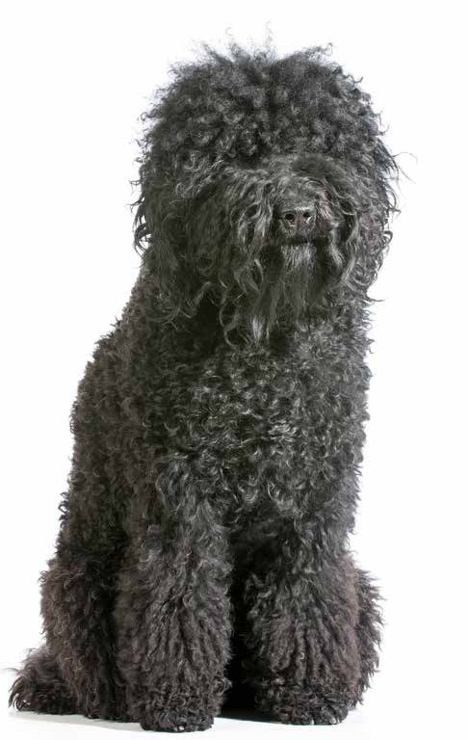

**The Barbet is an active, medium-sized water dog from France. This is a breed that enjoys working as well as playing, and many do very well in dog sports. They are known for their devotion to their human, and most prefer to be glued to their owner’s side.**

There are several theories on the breed’s history. Some claim the earliest references to Barbets in literature really refers to poodles. Others claim the breed’s history stretches into antiquity. Researchers subscribing to the latter theory believe the Barbet descends from herding dogs brought to Europe from North Africa with the Moors that occupied the Iberian Peninsula.

This would have been during the 7th and 8th centuries. From there, the dogs would have followed crusaders over the Pyre- nees to central Europe and France.

Other researches who also date the breed back to antiquity state that the Barbet originated in Asia and found its way to Eruope over land.

It is difficult to prove either theory, and the truth might very well be a mix of all of them.

Regardless of its history, these are dogs eager and quick to learn. As all intelligent breeds they need training and stimu- lation. They are often joyful and goofy, and love both children and other pets. Most Barbets love swimming, hiking, and traveling.

There is a big difference between the Barbet and other dogs; they have hair much like humans instead of fur. That means they don’t shed in the same way as most other breeds, but they require regular combing and trimming.

A barbet weighs between 40 and 60 pounds and needs a large PlexiDor dog door.

**Learn more about pet doors!**

### Visit [www.plexidors.com](http://www.plexidors.com/)

**Germans in general love pets, particularly dogs. If you visit Germany you will see pets everywhere. There are even public dog swimming pools.**

Not surprising, many popular breeds stem from the country and over forty popular dog breeds have their roots in Germany. Examples include the Boxer, Dachshund, Doberman Pinscher, German Shepherd, Pomeranian, Rottweiler, and Schnauzer.

# Germany

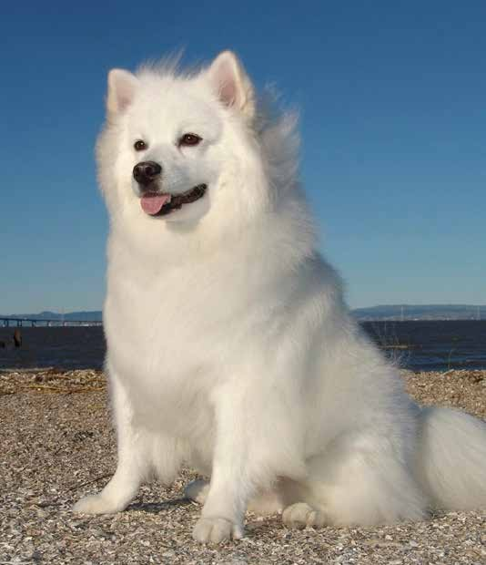

American Eskimo

**In spite of the name, the American Eskimo is a German dog. It was originally called German Spitz, but the breed received a new name after the First World War to keep its popularity up. The Eskie is a popular watchdog and companion. They also have a remarkable sense of bal- ance and can often be seen as circus performers.**

The American Eskimo looks a lot like a Samoyed or a Japanese Spitz, but these dogs have a completely differ- ent temper. They were originally bred to guard property and people, and they are valiant watchdogs when the occasion calls for it. They are devoted to their family and don’t appreciate being left alone.

Regular exercise is a must, as is regu- lar brushing and bathing.

There are three sizes; Toy, which normally weighs around 10 pounds, Miniature which weighs around 20 pounds, and Standard which weighs around 30 pounds. All sizes do well with a medium PlexiDor dog door.

*“We’ve had four 120+ pound dogs banging through the door no less than 50 times a day. You make a great product, please keep up the good work!”*

*Jim Grace*

34

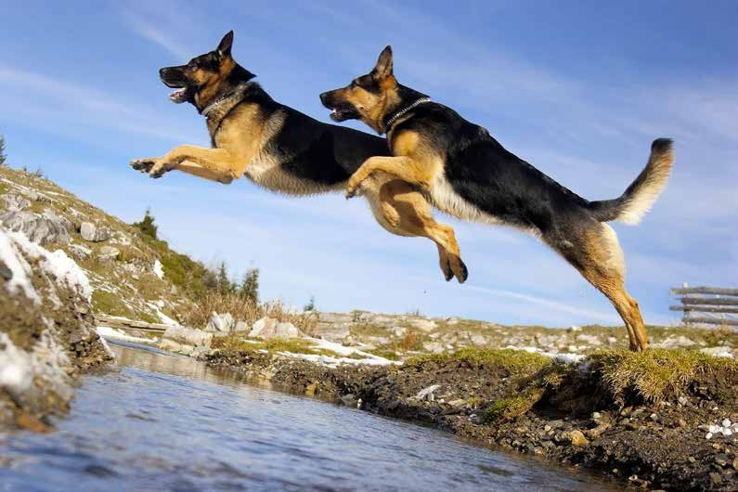

German Shepherd

**The German Shepherd was originally developed for herding and guarding sheep, but its intelligence and extraordi- nary focus on any task at hand has made it a popular choice for police and military all over the world.**

German Shepherds are strong, smart, loyal, and eager to please. They have been ranked third dog breed when it comes to intelligence - right after Border Collies and Poodles.

This is a breed that excels at guarding. They are protective towards family and home, and most of them are suspicious against strangers.

The German Shepherd is the most popular breed in a number of American cities, such as Buffalo, Chicago, Cincinatti, Detroit, and Miami. It is the third most popular breed in Seattle, Houston, and Portland, and the second most popular in Boston and Philadelphia.

German Shepherds normally weigh between 75 and 95 pounds, and need a large PlexiDor dog door.

**Get a PlexiDor product catalog!**

### Visit: [www.plexidors.com](http://www.plexidors.com/) Call: 800-283-8045

Dachshund

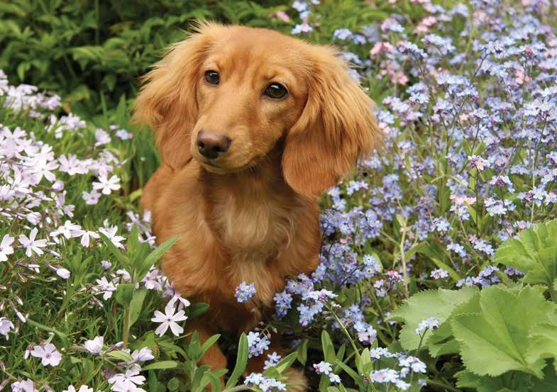

**The Dachshund is a lively and friendly dog breed with German origin. The breed stems back to the 1600s, and the dogs were bred to be tough and fearless enough to dig underground and fight badgers.**

Dachshunds are enthusiastic, playful, and loving. They require moderate exercise and generally do well with children. This breed tends to get bored easily, so be prepared to keep your furry friend busy and load up with fun toys.

There are three different coat varieties: smooth, wire-haired, and long haired. Both the smooth and wire-haired dachshunds shed very little. The dogs can come in standard size or miniature.

A standard Dachshund weighs between 16 and 32 pounds, and a medium PlexiDor dog door is a good choice. A miniature weighs under 11 pounds. Some can use a small PlexiDor, but most will require a medium.

*“The pet doors have paid for themselves tenfold and the dogs love them. We’re extremely happy with the decision to purchase PlexiDors.”*

*Roger Goedde*

36

Leonberger

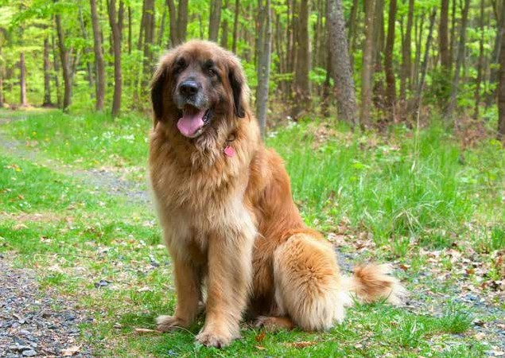

**The Leonberger is a very large dog known for being friendly and eager to please. The breed originated in Germany in the 1800s, and they are wonderful family dogs. Many also excel as working dogs in many fields, particularly as therapy dogs.**

When looking at a Leonberger, speed and agility might not be words that come to mind, but these dogs are surprisingly energetic, light on their feet, and agile. They need exercise, but to well in all sorts of living quarters. To a Leonberger, being with the family is more important than having lots of room.

Most Leonbergers love to swim - they even have webbed feet - and they are good at water rescue. They are also generally good with children and other pets; they were originally bred to be reliable family dogs.

They are related to Newfoundlands as well as Pyrenean Mountain Dogs and St. Bernards, and they have a thick coat that sheds profusely. A Leonberger owner should be prepared for brushing the dog on a regular basis.

**Get a PlexiDor product catalog!**

### Visit: [www.plexidors.com](http://www.plexidors.com/) Call: 800-283-8045

Doberman Pinscher



38

*“This door is fantastic. My old door deteriorated after about a year of use with the rubber flap ripping, falling out, and letting in the cold air during the winters. With the PlexiDor the rear of my house is no longer cold due to drafts, and it’s easier for my pets to use. Also, it looks much, much nicer. This door is worth every penny.”*

*Jeanne Drust*

**The Doberman Pinscher stems from the town of Apolda, Germany, and the breed was first created in the late 18th century. The creator, Karl Friedrich Louis Dobermann, served as tax collector and he needed a companion that had to be strong, fast, loyal, and intelligent.**

To reach his goal, he bred many different kinds of dogs together including the Beauceron, Rottweiler, Greyhound, Great Dane, and the Weimaraner. The exact mix of dogs is unknown today.

The dogs are known for a their loyalty, intelligence, and high trainability. They are considered working dogs, and many serve as police dogs and military dogs. Their energetic, fearless, and obedient nature make them perfect for the job. They also make fantastic canine athletes.

These dogs have a short coat and only need minimal grooming. They do need plenty of exercise - they are consid- ered very active and need something to do to stay healthy and happy.

Dobermans are large dogs and require a large PlexiDor dog door.

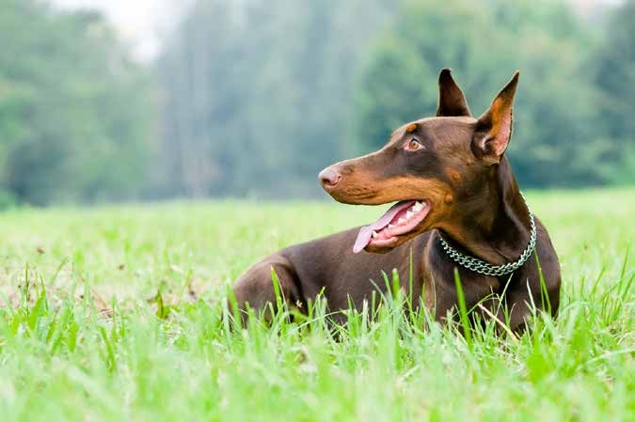

Rottweiler

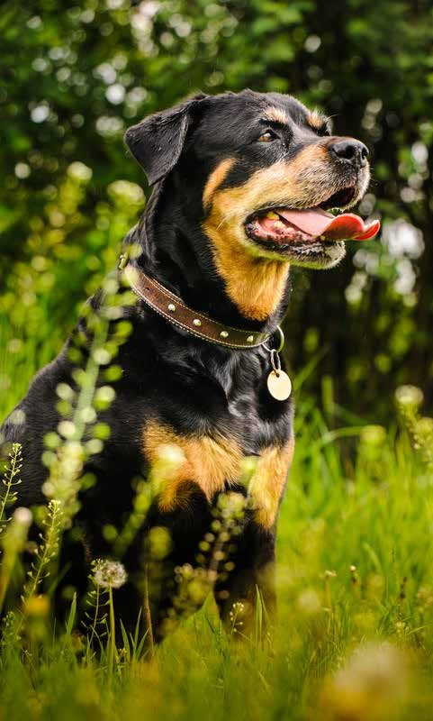

**The Rottweiler is a robust breed who likes to have a job to do. The dogs are intelligent and self-confident, and often used as police dogs, service dogs, therapy dogs, or even as herders.**

The breed is believed to stem back to ancient Rome, and arrived to Europe with Roman invading forces. Whey they reached Germany, the locals appreciated the dogs’ herding and guarding instincts, and kept breeding them to enhance these skills.

Rottweilers are believed to have herded animals in Germany for at least 2,000 years, until the industrial revolution took over and the dogs’ services were no longer needed. The breed nearly fell extinct, but a breed club was formed in the early 1900s and saved it.

Rottweilers love their family and are generally good-natured and patient. They need a lot of exercise, but little grooming.

Females generally weigh between 77 and 105 pounds and do well with a large PlexiDor.

Males weigh up to more than 130 pounds and need an extra large PlexiDor dog door.

**Learn more about pet doors!**

### Visit [www.plexidors.com](http://www.plexidors.com/)

**The Vizsla is probably the most popular dog breed associated with Hungary, but many working breeds come from this area.**

Hungarian dog breeds include the Komondor, Kuvasz, Mudi, Puli, and the Transylvanian Hound.

# Hungary

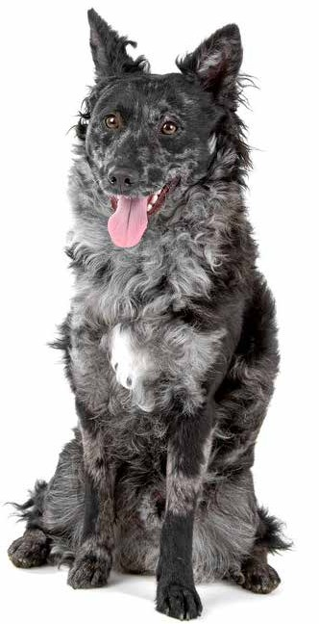

Mudi

**The Mudi is a Hungarian herding breed that stems back to the 15th century. Many confuse it with the Pumi or the Croatian Puli, some even call the breed Puli, and the breeds share a common past.**

This is a fascinating breed because it was discovered as a naturally occurring shepherd’s type of dog. It might be a natural mix of the Pumi, Puli, and German Spitz type of dogs. The Mudi breed counts as naturally developed, and this is the last natural breed of its kind that still works with livestock and shepherds.

Many claim that this is one of the best herding breeds. The Mudi also makes a good companion, watchdog, and hunting dog. Like most herding breeds it does very well in various sports; these are great dogs for agility.

An average Mudi loves to play and swim. They will easily learn to play ball or frisbee, and they make great jogging companions.

The breed is great for families with children, houses with yards, and active people. Just watch out if the dog is left alone outside; they are notoriously good diggers and can dig their way under a fence.

A Mudi generally weighs between 17 and 29 pounds and a medium PlexiDor dog door is a perfect match.

*“I purchased an extra large dog door and just wanted to let you know how incredible it is! I have a 135 lb Rottweilser and a 100 lb American BullDog that are trying their best to break the acrylic panes. I think the house will come down before the dog door!”*

*Britt Autry– Aurora, CO*

40

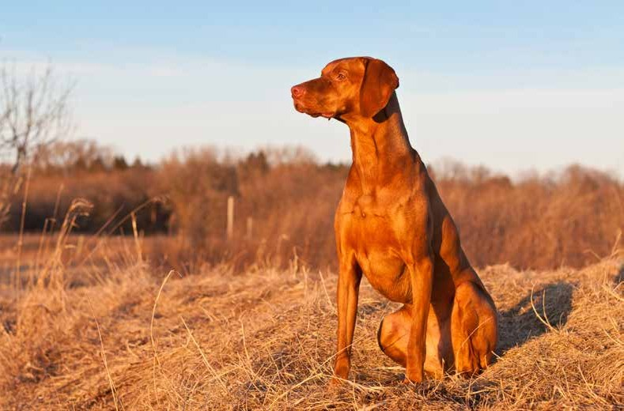

Vizsla

**The Viszla is a dog breed originating in Hungary, known for being athletic and loyal companions. The breed is also called Hungarian Pointer.**

This is a natural hunter equipped with an excellent nose and outstanding trainability. They are lively, gentle mannered, and affectionate, but also fearless and protective when need be. Some people call them “velcro dogs” because of their loyalty and affection.

The ancestors of the Vizsla are assumed to have been hunters accompanying Magyars to central Europe over a thousand years ago. The breed is depicted in etchings that date back to the 10th century, and manuscripts from the 14th century.

A Vizsla thrives on attention, exercise, and interaction. They are often vocal. They sing along with the radio, and cry when they feel neglected.

The Viszla generally weighs between 40 and 66 lbs, and requires a Large PlexiDor Dog Door.

**Get a PlexiDor product catalog!**

### Visit: [www.plexidors.com](http://www.plexidors.com/) Call: 800-283-8045

Komondor

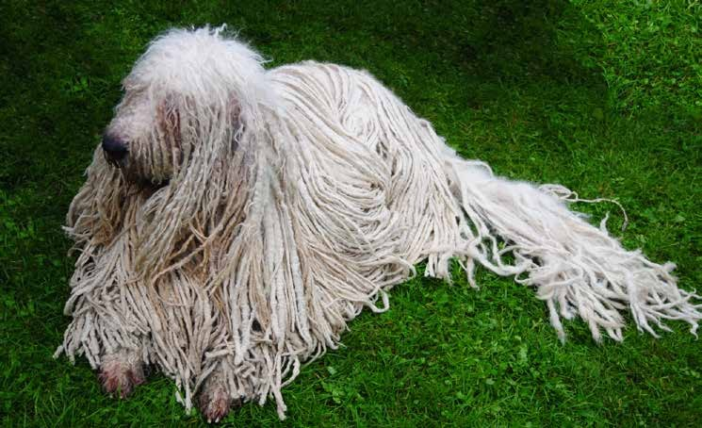

**The Komondor is a Hungarian breed that arrived to Europe from Asia between the years 900-1100. It is descended from Tibetan dogs, and has worked with sheep and cattle in Hungary for over 1,000 years.**

This is a herding breed, but rather than rounding up herds or flocks, the Komondor follows the animals and protects them, usually without assistance from a human. Here, the eye-catching coat has a practical purpose; it helps protect the dog in case of attack. Wolves are not able to bite through the thick coat.

The Komondor is a very large breed that often grows over 30 inches tall. They’re known to be calm and steady when things are normal, and they are responsible and loving towards their families. If there’s trouble, the dog will defend its charges.

Komondors have been bred to think and act independently and make decisions on their own, which can create problems in the modern world if the dog isn’t trained. Training sessions need to be upbeat and happy, and the dogs thrive on praise.

These dogs often rest during daytime, and patrol during night time. If a Komondor would discover an intruder, they’re known to knock them down and keep them down. Hungarian Komondor breeders say, “an intruder may be allowed to enter, but he will not be allowed to leave.”

The Komondor requires daily exercise and obedience training. They don’t shed much, but they need help in separating the cords so the coat doesn’t turn into a huge, matted mess. They need baths just like all dogs, but the coat needs about two and a half days to dry.

*“My English Bulldog loves the door, and so do I. It was so easy to install, and it operates very qui- etly. I am amazed at how air-tight this door is. There is no problems with drafts. I highly recom- mend it to all my friends with pets.”*

*Nancy Pack – Corbin, KY*

42

Hungarian Puli

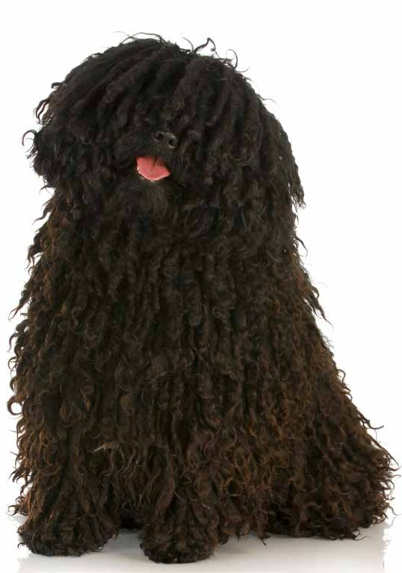

**The Puli is a Hungarian dog breed used for herding and guarding livestock. The dogs are fairly small and easily recognizable because of their long, corded, and waterproof coat.**

These dogs are active and intelligent. They may look bulky and slow, but the thick coat hides a dog that is fast, agile, and able to turn around corners like a sports car.

Many Pulis keep a playful behavior their entire life, but they can also be quite focused if they have a job to do. If you’re considering a Puli, remember that this is a herding breed, and they will herd.

This is an old breed, believed to have been introduced to Hungary more than 1,000 years ago when they migrated with the Magyars from Central Asia. The breed itself is believed to date back at least 2,000 years, and some scientists believe it may be as old as 6,000 years.

In Hungary, the Puli would often work together with the Komondor. The Puli herded and guarded the sheep at day, getting help from the Komondor if large predators attacked. The Komondors would keep guard at night, patrolling the area around the flock.

Pulis are generally black, but they can also be white, gray, or cream.

**Get a PlexiDor product catalog!**

### Visit: [www.plexidors.com](http://www.plexidors.com/) Call: 800-283-8045

**Quite a few dog breeds have originated in Ireland, and many of them are popular around the world today.**

Dog breeds from Ireland include the Glen of Imaal Terrier, Irish Setter, Irish Wolfhound, Kerry Blue Terrier, and the Irish Water Spaniel. There is also a Kerry Beagle that stems from Ireland, and this breed is believed to be one of the oldest Irish Hounds.

# Ireland



*“My dogs race each other to see who gets through the PlexiDor first. The door is still good as new, 4 years later! I get extreme cold and extreme heat/humidity in Michigan, and my door has performed beautifully.”*

*Noura Bashshur – MI*

44

Glen of Imaal Terrier

**The Glen of Imaal Terrier is a tough and small terrier breed native to Ireland, stemming back to the 16th century. They were originally bred to keep homes and farms free from vermin, and to hunt badgers and foxes.**

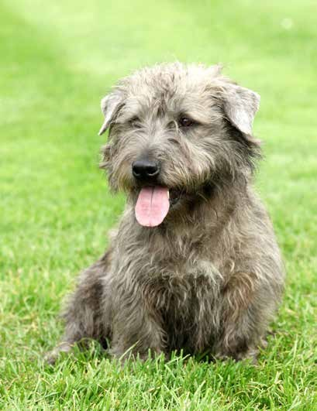According to the lore, these dogs had one more important job, and they would be the only dogs in the world specifically bred to perform it: they were turnspit dogs.

A turnspit is a large wheel that the dog would paddle, and the wheel turned a spit over the hearth, like a dog-powered rotisserie. It is difficult to verify today whether this is true or not, but it might be.

These dogs are considered a “big dog on short legs” and weigh around 36 lbs. They’re known to be active, agile, and intent on whatever they’re doing, and as many other terriers, they can have a mind of their own. However, they don’t bark much. They love activity, but can relax indoors, and do well in families with older children.

The first Glen of Imaal Terriers to arrive to the USA came with their owners in the 1930s. They’re not amongst the most common breeds today, but there is a breed club.

The Glens are generally strong and healthy with an average life span of 15 years.

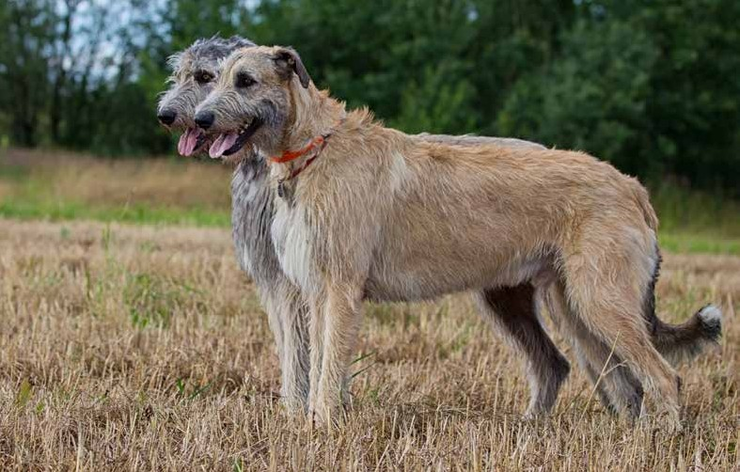

Irish Wolfhound

**The Irish Wolfhound is the tallest dog breed. The current world record holder of tallest dog is a Great Dane, but taking an average of individuals in a breed, the Irish Wolfhound would win without contest. They are also superb athletes with great stamina, and they can run quickly for long periods of time.**

This breed has been around for a long time – the oldest references stem back to Roman records from around 390 AD. Today, many think the name comes from the dogs’ ragged appearance, but they were originally bred to hunt wolves. These versa- tile dogs would hunt with their humans, fight in battle, guard homes, and play with the children.

Irish Wolfhounds are known for being calm, kind, dignified, and courageous. This is not a breed that gets into trouble, but they do have hunting instinct and will give chase. It might be tempting to think a dog this size would make a great guard dog, but except being big they’re much too friendly to work as watch dogs or patrol dogs. A typical Irish Wolfhound will think the best of all people, unless their own humans are physically attacked.

The mere size of the breed can be a challenge for owners – a Wolfhound standing on the hind legs can reach seven feet. The coat doesn’t require much grooming, but dogs this size require lots of room, lots of exercise, and a big car.

**Learn more about pet doors!**

### Visit [www.plexidors.com](http://www.plexidors.com/)

Kerry Blue Terrier

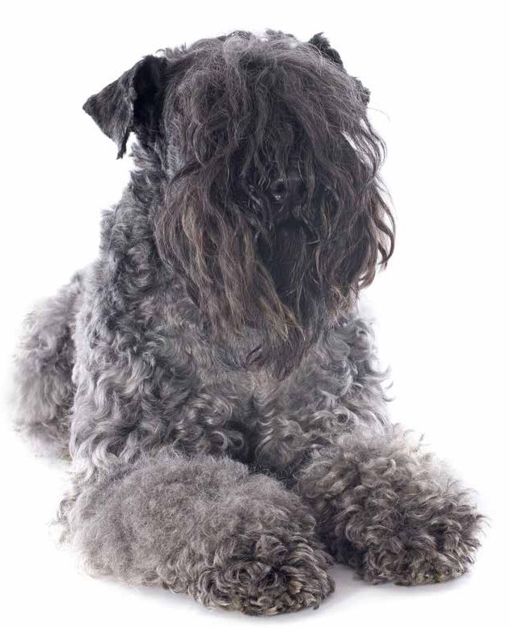

**The Kerry Blue Terrier originated in Ireland, and has been used for hunting, retrieving, and herding both sheep and cattle. The Irish commoners developed the Kerry when the nobility started to use Irish Wolfhounds to protect their hunting grounds from poachers. The Kerry Blue Terrier helped the commoners to keep hunting, in silence, without risking discovery.**

These dogs have a distinctive appearance with a soft, dense, and wavy coat. They shed very little, but still require regular grooming and should be brushed and trimmed regularly. As adults they’re gray, but the puppies are born black and their coat will fade until their around 18 months old.

Kerry Blue Terriers are energetic and active dogs that do best in active families. They love to dig and to chase things, and they require lots of exercise. Without both physical and mental stimulation they get bored and can become destructive. This breed was created to work, and they do best with a job to do.

A typical Kerry loves people and is devoted to the family, but owners should be aware that the breed still has a strong

hunting instinct. Early socialization with other dogs, cats, and other animals is a must to get a dog that will get along with others. These dogs can be quite stubborn as well, and require training.

A Kerry Blue Terrier weighs between 33 and 40 lbs and most will do great with a medium PlexiDor dog door. Large individuals might need a large PlexiDor dog door.

*“Wind up here often blows at a steady 30-40 mph, but the door stays shut and the room warm. A few moths ago we had a very bad hail storm with over $11,000 damage to siding and roof. The door stayed shut!”*

*Susan Owen – Mandan, ND*

46

**Israel is only associated with one dog breed, but the breed is mighty and has seen and survived the birth of at least three religions. The Canaan dog today is basically the same as the dogs mentioned in the Bible, and it is one of the most ancient breeds in existence.**

Canaan Dog

**The Canaan Dog is considered a natural dog breed, which means it has developed with little selective breeding from humans. These dogs have been in existence for at least 2,000 years, and the breed might be even older. There are drawings of dogs looking just like it dated back to 2,200 BC.**

This was the guard and herding dog of the ancient Israelites, and when then they were dispersed by the Romans over 2,000 years ago, the dogs avoided extinction in the Negev Desert. Some lived with the Bedouins, and some were used as guard dogs for the Druze people.

Today the Canaan Dog is quite rare. There are somewhere between 2,000 and 3,000 Canaan dogs in the world.

Being herding dogs and guard dogs they can be territorial and are often reserved with strangers, but they are also quite affectionate with their families.

Canaan dogs are versatile and intelligent. They are easy to train, but quite independent, and they need both physical and mental stimulation to stay happy. They are often seen winning agility trials, competing in flyball, or doing well in obedience.

The Canaan dog is generally tan or black-and-white with curled tail, pricked, pointy ears and almond-shaped brown eyes.

# Israel

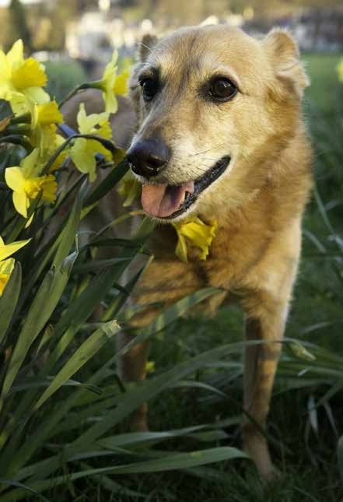

**Get a PlexiDor product catalog!**

### Visit: [www.plexidors.com](http://www.plexidors.com/) Call: 800-283-8045

**PlexiDor**® **Door Unit**



*“This is the first testimonial I have ever written for a product I have bought. I had to write it, be- cause it was so well deserved. The door is worth every penny and then some!”*

*Giesele G. Matthews – Kirkwood, MO*

48

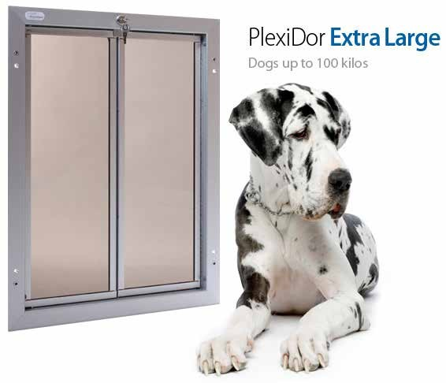

#### Easy and Professional Door Installation

The PlexiDor® Door Unit has a frame made to fit a standard exterior house door. The frame will protect the cut-out edges of a solid wood or metal door, and eliminate the need to frame in a hollow core door.

Tools needed for installation are: saw, drill, and screwdriver.

Small

The small door is ideal for cats up to 24 lbs and dogs up to 9 lbs. This is a single panel design, and the energy efficient acrylic thermopanel opens from left to right with precision smoothness. Even the smallest kitten or puppy can push the door open.

This door has a spring-loaded 4-way lock. It can be set to IN ONLY, OUT ONLY, IN AND OUT, or LOCKED. The small units do not come with a steel security plate.

Medium

This is a perfect door for dogs up to 40 lbs. The door has shatter resistant, dual thermo-pane acrylic panels that open with a gentle push and close tight without banging. Each panel is lined around all four edges with snug fitting, high density, industrial weather seal. The door provides superior draft control.

Large

The large door shares the design and features of the medium door, but is intended for dogs weighing up to 100 lbs. Just like all PlexiDors, it reduces air conditioning and heat loss.

Extra Large

The panels on the PlexiDor PD Door XL and PD Wall XL are manufactured using a solid 3/₈” sheet of shatter resistant acrylic, and they are virtually indestructible. The door is suitable for larger dogs up to 220 lbs. The panels also come equipped with factory installed chew proof aluminum trim around all four edges and on both sides of the panel.

**PlexiDor**® **Wall Unit**

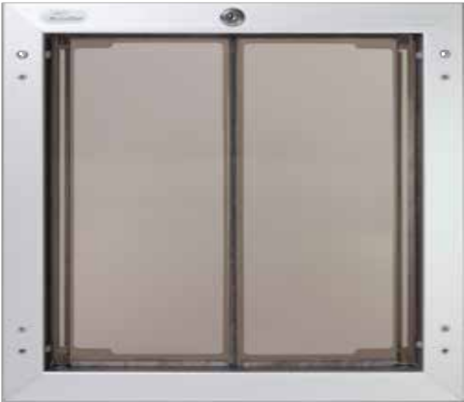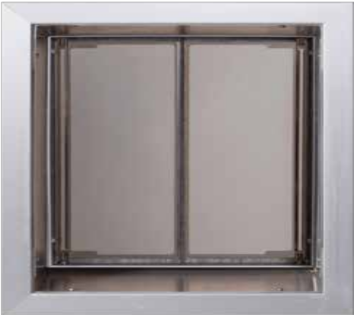

**Exterior view (outside of home)**

**Interior view (inside of home)**

#### The best way to install a pet door through a wall

The PlexiDor® Wall Unit will give you a professional grade wall installation.

The Wall Units can be installed into stud, brick, block, or cement walls up to 12 inches thick. Each wall unit includes a sloped aluminum tunnel that connects the interior and exterior frame. The tunnel materials

A Large PlexiDor® Wall Unit fits exactly between studs 16” on center

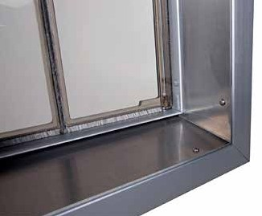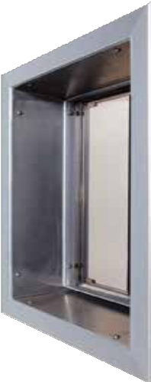

ensure a professional fit and finish.

**Aluminum Tunnel**

The bottom tunnel section is sloped to prevent water from entering. The tunnel will not rust, and is easy to keep clean.

The tunnel is 12 inches deep. You trim it down to the

width you need with included jigsaw blade or tin snips.

Tools needed for installation are: jigsaw, drill, and screwdriver. A jigsaw blade is included with the unit.

You can also build a tunnel like the tunnels used for the windows in your home, and install a PlexiDor® door unit in the tunnel.

A Large PlexiDor® Wall Unit fits exactly between studs 16” on center

Tools needed for installation are: jigsaw, drill, and screwdriver.

An aluminum jigsaw blade is included with the unit.

You can also build a tunnel like the tunnels used for the windows in your home, and install a PlexiDor® door unit in the tunnel.

**Learn more about pet doors!**

### Visit [www.plexidors.com](http://www.plexidors.com/)

**Around thirty dog breeds have their roots in Italy, or are at least related to the area. Many are spe- cialized, like the Cirneco dell’Etna that has been used to hunt together with ferrets.**

Dog breeds from Italy include the Bergamasco Shepherd, Bolognese, Cane Corso, Volpino Italiano, Maltese, Lagotto Romagnolo, Italian Greyhound, and more.

# Italy

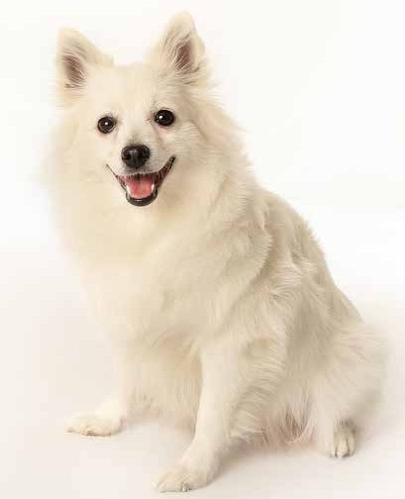

Volpino Italiano

**The Volpino Italiano is a small spitz type of dog from Italy. It is related to other European spitz breeds such as the American Eskimo, and many of these breeds have developed side by side through the past 4,000 years.**

In the past, the Volpino would be used as guard dog. The dogs are too small to be much of a threat to an intruder, but they would work in pairs with mastiffs. If the alert Volpino sensed any danger they would bark to get help from the large dog.

The Volpino Italiano has been called the dog of Michelangelo and the breed was historically very popular in Italy, but almost died out during the mid 20th century. Today there are around 2,000 Volpinos around the world.

They are known for being energetic and friendly. These dogs get tightly attached to their families, and they are intelligent, happy, lively, and playful. It is a hardy and healthy breed with an average life expectancy of 14 to 16 years.

An average Volpino generally weighs between 9 and 12 lbs, so a small individual might get by with a small PlexiDor dog door, but the majority will need a medi- um PlexiDor dog door.

*“When I installed the door I wondered how long it would actually last. Prior to this we’ve had two other doors from other manufacturers, and one lasted for only three hours before being broken beyond repair. We’ve had your door since 2002 without a single problem. It withstands daily use from two 80-pound dogs.”*

50 *Brian G. Kelly*

Bergamasco

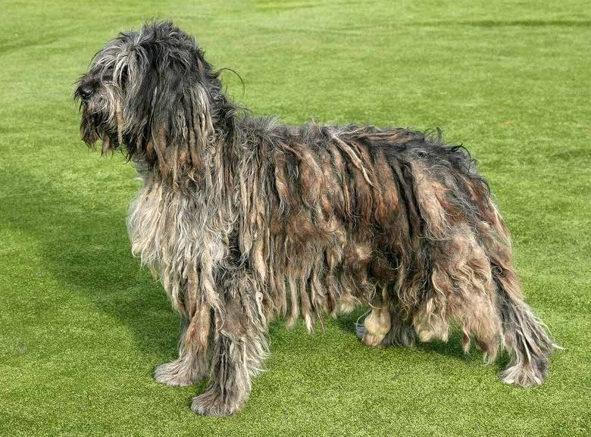

**The Bergamasco is believed to be a descendant of longhaired sheep dogs brought to Italy by the Phoenicians. This intelligent and hard working breed can be traced back almost 7,000 years.**

The most eye-catching aspect of the breed is the unusual felted coat. It consists of three types of hair: a fine, dense, and oily undercoat, long hairs similar to a goat’s, and a wooly outer coat. The mats “set” at age one, and after that the coat requires little maintenance. A Bergamasco should be bathed 1-3 times per year. They shed very little, and should not be brushed.

Bergamascos are known for being very sociable and having a strong work ethic. They think independently and are very intelligent. If you want a subordinate to the other members of the family, a Bergamasco is not a good choice; they tend to see themselves more as an equal that works together with the humans.

This breed is also known for its almost supernatural hearing, and for being good judges of character. As long-time protectors of herds they can predict violence, and they are reliable predictors of approaching visitors and violent behavior.

**Get a PlexiDor product catalog!**

### Visit: [www.plexidors.com](http://www.plexidors.com/) Call: 800-283-8045

Cirneco dell’Etna

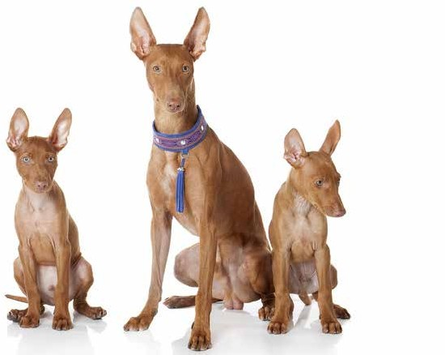

**The Cirneco dell’Etna comes from Sicily, and has been present in Italy for at least 2,500 years. Images of the breed has been found on old coins dated back to around 500 BC when Greece colonized Sicily.**

Etna is the largest active volcano in Europe, and these dogs are bred to work on rugged terrain formed by volcanic lava. They hunt small mammals and fowl, and can withstand heat for hours with no food or water. The traditional way of hunting pairs the Cirneco with a ferret. The breed has an extraordinary sense of smell, and when the dog found rabbits, the ferret would flush them out.

This breed has developed with little manipulation from humans, and they are very hardy. They are known to be indepen- dent and strong, but also affectionate and friendly with people. They are are intelligent, and require mental stimulation as well as exercise. The average Cirneco dell’Etna is a great jumper and digger, and it is important to keep a yard secure.

*“I have nine Rottweilers and a cat that bang (not walk) through the door a thousand times every day and night. It is incredible how much wear and tear these doors will take.”*

*Sandra Jones*

52

**Dogs native to Japan are generally of the northern type, and breed differences lie in sizes, colors, users, and other minor differences.**

While the Japanese breeds are undisputably separate breeds, they are still so much alike that in Japan they’re often shown in one classification divided into sub groups.

Some breed considered Japanese, like the Japanese Spitz, Japanese Chine, and Japanese Terrier have ancestors from other parts of the world. Others, like the Hokkaido dog, Shiba Inu, Kai Ken, Kishu dog, and Shikoku Inu, have a long history and are all created by ancient Japanese hunters.

Japanese Spitz

# Japan



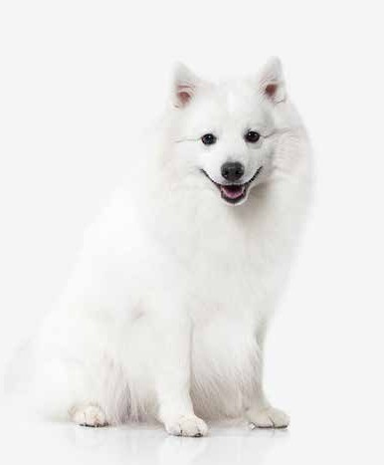**The Japanese Spitz was developed in Japan in the 1920s by breeding other Spitz type dogs together. It started with white German Spitz dogs that were bred with other dogs from around the world.**

The Japanese Spitz was exported to Sweden in the early 1950s and is still a common breed there. From Scandinavia they went to England, and has since spread around the world.

An average Japanese Spitz is active, smart, and loyal, and they are known for being brave and devoted. Despite their small size they’re alert watch dogs and tend to bark at strangers. They are generally good with children, and enjoy being active with their family. The breed was created to be companions, and they want to be close to their people.

This is a healthy breed with a life expectancy of ten to sixteen years.

**Learn more about pet doors!**

### Visit [www.plexidors.com](http://www.plexidors.com/)

Tosa

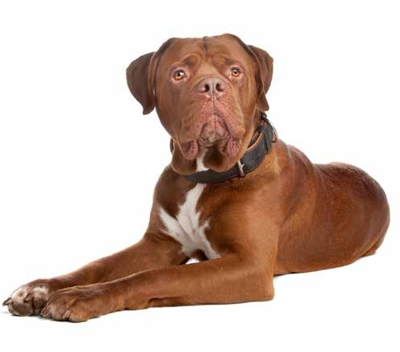**The Tosa is a Japanese breed of dog, at least 1,000 years old. They were traditionally used for dog fighting, and through the centuries the breed has changed from a small spitz type to today’s large and muscular dog.**

Before the start of WWII there were thousands of Tosa breeders in Japan, but when the country entered the war they made dog fighting illegal. In an attempt to discourage illegal fights, raising dogs of 150 lbs was also made illegal. The breed would have gone extinct, but a few of the most passionate breeders smuggled the last remaining dogs to northern Japan and hid them until the end of the war.

Today, the breed has split into two groups. The Japanese bred are smaller and generally weighs between 80 and 135 lbs. Non-Japanese bred weigh between 135 and 200 lbs. With such a massive size it’s a good thing that they’re known for having a stable temperament. Back in the day when the Tosa was bred for dog fighting they had to be quiet, because Japanese rules demanded silence.

To this day they rarely bark, but when they do it’s a deep rumbling sound that combined with the massive size efficiently keeps intruders away.

These dogs are known to be fearless, brave, and intelligent. They are loyal to their family, but like all breeds they require training and socialization.

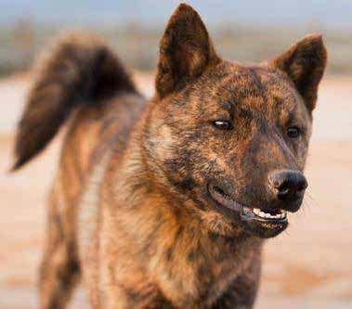

Kai Ken

**The Kai Ken is a Japanese breed that is considered rare even in its own country. They are intelligent, alert, brave, and agile, and known for being reserved with strangers while loyal to their families.**

The Kai is a natural hunter, quick to learn, healthy, and athletic. The average Kai Ken loves to swim, and they can cross rivers and even climb trees. The average life span ranges from twelve to well over fifteen years.

This is considered the most ancient and purest dog breed in Japan, developed in a district isolated by mountains and water, and the Kai Ken was designated a “Natural Treasure” in Japan in 1934. The dogs are protected by law.



*“The PlexiDor is everything you said it was and more. The nicest part is that it doesn’t allow all the drafts we experienced with our old pet door.”*

*J. Foster – Florida*

54

Akita

**The Akita is a working breed from Japan, known for its unfaltering loyalty to its family. There are many stories of the loyalty of an Akita, and the breed was declared a Japanese Natural Monument in 1931. Considered a national treasure, there is even an Akita Dog Museum that houses information, documents, and photos.**

World War II pushed the breed close to extinction, and after the war the Japanese Akita and American Akita began to take different paths. American Akitas have become larger and heavier, while the Japanese breeders have focused on maintaining the national monument’s original appearance.

An Akita thrives on human companionship. These dogs can be goofy and silly when around their family, and are miserable if not allowed to be with their humans. They are intelligent and independent thinkers, powerful, alert, and courageous.

These dogs are popular for performance sports and therapy work. In Japan they’re often used as hunting dogs, and they are nick-named the “Silent Hunter” because even though they are quite able to bark, they rarely do.

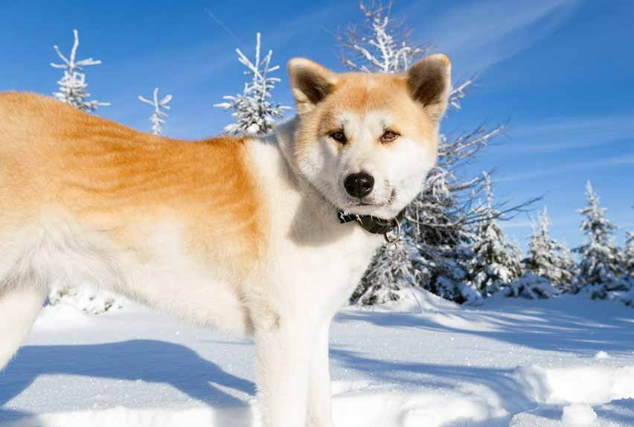

**Get a PlexiDor product catalog!**

### Visit: [www.plexidors.com](http://www.plexidors.com/) Call: 800-283-8045

**A handful of dogbreeds has originated in Korea; the Jeju dog, Korean Jindo, Nureongi, Pungsan Dog, and Sapsali. Of these, the Jindo is the most known in the west.**

The Pungsan dog is a hunting dog named after the northern county of Pungsan. They are a very rare breed mixed with wolf known to be loyal to their owners while ignoring everyone else. The breed is famous for cleverness and loyalty.

The Sapsali is believed to dispel ghosts and evil spirits, and has been designated as a national treasure. They

are known for being extremely patient and congenial towards other animals as well as humans.

# Korea

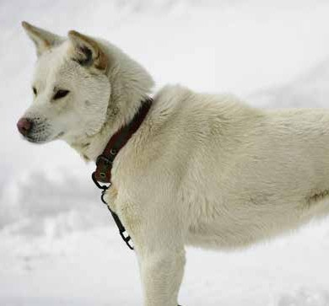

The Jeju Dog was brought back from the edge of extinction in 1986 when three of them were found on the entire island of Jeju. Since then an aggressive breeding campaign have yielded a population of around 300. The Nureongi is a breed not normally kept as pets.

Jindo

**The Jindo gets its name from the Korean Jindo island. The breed is believed to be ancient, and the dogs are known for being loyal and brave. In Korea, the Jindo is considered a national treasure.**

The breed divided into two groups. The Tonggol or Gyupgae are stocky, muscular, and have a deep chest. This version of the breed has an equal proportion of height at the withers and length. The Hudu or Heutgai are slender with less deep chest. Nowadays the Korean National Dog Association recognizes one more body type; the Gakgol which is a combination of the Tonggol and the Hudu.

The dogs come in five colors. White, Fawn, Grey, Black and tan, or Brindle.

Jindos are highly intelligent, independent, and strong willed. They tend to be suspicious towards strangers, but are loving and protective towards the family. They make great pets as long as they have mental and physical stimulation and interaction with people or another dog.

The breed’s loyalty is the basis of Korean cartoons, documentaries, and even children’s storybooks.

*“It is great to deal with a company that is not trying to rip people off. My dogs absolutely love the door. I will not hesitate to recommend your company to anyone looking for a good product and an honest company.”*

*C. Andrade*

56

**Malta is a mediterranean island, and one of the world’s smallest and most densely populated countries. The island has two official languages: Maltese and English.**

Two dog breeds are closely associated with Malta; the Maltese and the Egyptian Pharaoh Hound. Some scientists say the latter is related to domesticated Egyptian dogs traced back to 3000 BC. Others say the Pharaoh Hound comes from Malta and that there’s no DNA evidence proving the breed is related to the Egyptian dogs. Read more about the Pharaoh Hound on page 25.

# Malta

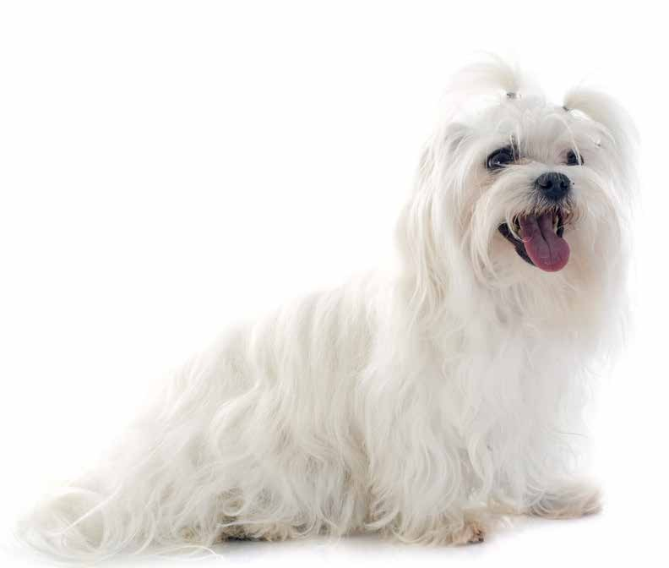

Maltese

**The Maltese is a gentle and affectionate toy breed known for being play- ful, lively, and fearless. These clever little dogs have been considered dog aristocracy for 3,000 years and the breed has a rich history.**

Other small breeds have been bred down from larger sizes, but the first Maltese were the same size as the dogs of today, and even though they’re small, Maltese tend to be brave.

The long and silky coat lacks an undercoat and the breed sheds next to nothing. Many choose to cut the coat to minimize the amount of brushing.

These dogs are lively and playful, and generally cuddly. They like company and adore their humans.

**Get a PlexiDor product catalog!**

### Visit: [www.plexidors.com](http://www.plexidors.com/) Call: 800-283-8045

**Mexico is mainly associated with the Chihuahua and the Xoloitzcuintli, also called Mexican Hairless Dog.**

Many also associate Mexico with the Chinese Crested, because of genetic evidence showing the breed shares the origin of the Xoloitzcuintli.

# Mexico

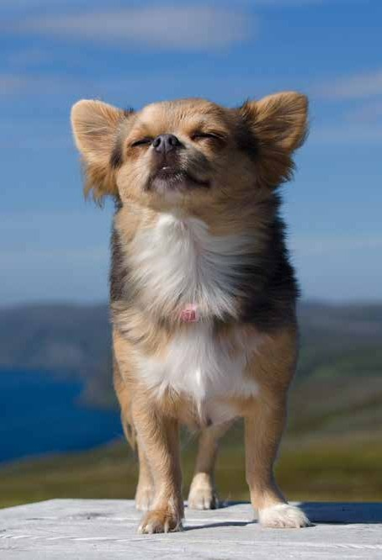

Chihuahua

**Chihuahuas are generally considered the smallest dog breed. There are two main varieties: short haired and long haired.**

The Chihuahua gets its name from the Mexican state Chihuahua. Pictures resembling the breed has been found on ancient paintings, and the dogs are believed to be decendent from a dog indigenous to Central America called the Techichi.

Chihuahuas are alert and energetic, but they still require little exercise, because they’re so small. A stroll for a human is a long way to walk for a Chihuahua. While they like to run and play, they

also love sitting curled up on their favorite human’s lap.They make great city dogs and require little grooming.

One thing to keep in mind is that these small dogs are fragile. They need to be treated with care, and small children might be too rough and hurt the dog. They were bred to thrive in a warm climate, and many dislike cold. They tend to seek out sunshine or burrow themselves down under piles of blankets.

These dogs are clever and enthusiastic, and usually have large personalities.

*“The PlexiDor pet door looks nice on both the inside and outside of the house – better than I thought it would. And we’ve had -34 C this year after it was installed with no draft from the door. The front of the door didn’t feel any cooler than the rest of the wall next to it. Well insulated.”*

*Kaylendra – Canada*

58

Xoloitzcuintli

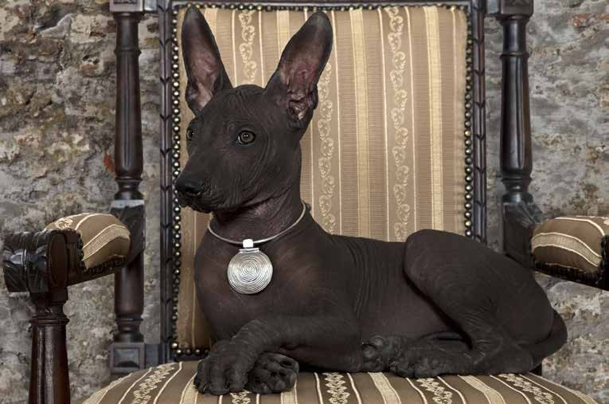

**The Xoloitzcuintli is a rare and old dog breed. Some sources claim it is the world’s oldest, and rarest. It is believed to be the first dog of the Americas and came across the Bering Strait together with the first humans migrating to the continent.**

The exotic name comes from the Aztec god Xolotl combined with the Aztec word for dog: Itzcuintli. The breed is also called “Mexican Hairless” or “Tepezcuintli.”

The Xolo is reputed to be a healer, and in the past its presence has been believed to cure rheumatism, asthma, toothaches, insomnia, and more. They are also believed to guard the home from evil spirits as well as human intruders. The Aztecs be- lieved the Xolo was tasked with bringing souls to the afterlife.

These dogs make great companions, and are generally calm, tranquil, loyal, and intelligent.

There are three sizes of the Xolo: Toy stands 10-14 inches at the shoulder, Miniature 14-18 inches, and standard, 18-23 inch- es. With a size range between 10 and 50 pounds, most Xolos will be able to use a medium PlexiDor, but some might need a large door.

**Learn more about pet doors!**

### Visit [www.plexidors.com](http://www.plexidors.com/)

**Morocco is located in west Africa, and this is one of only three countries that have coastlines facing both the Atlantic and the Mediterranean. It looks**

**like a small country on a map, but that’s just because Africa is so big. Morocco has a population of over 35 million people.**

Famous dog breeds from Morocco include the Sloughi and the Aidi. The Sloughi is an energetic hound used for hunting that often works together with the Aidi.

Aidi

**The Aidi – or Atlas Mountain Dog – is a Moroccan dog breed. It is also called Chien de l’Atlas. This is an energetic working dog believed to have originated in Sahara.**

In its homeland, the Aidi often protects herds of sheep and goats. They are also good at hunting and track- ing scents. For hunting, an Aidi is often paired with

a Sloughi, a type of hound that chases down prey tracked by the Aidi. The breed is gaining popularity as city pet, but most of them are still hard workers, either in the countryside or as police dogs.

A typical Aidi is highly protective, alert, powerful, and always ready for action. As many working dogs, it does best with an experienced owner and a job to do. They need ample amounts of exercise, long daily walks, and prefer to have a large yard.

These dogs can come in a variety of colors and color combinations. They’re considered healthy, and have an average life span of 12 years. A typical Aidi weighs around 50-55 lbs, and requires a large PlexiDor dog door.

# Morocco

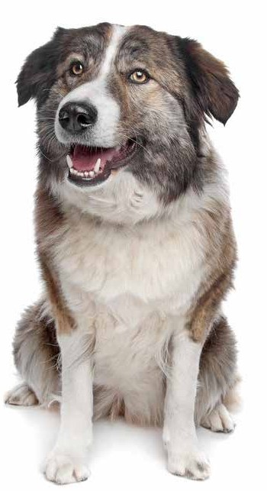



*“Boone, my Brittany, has used one of your PlexiDor dog door wall units for four years. The door is still as good as new, and I’ve performed no maintenance on it. It is flawless.”*

*J. Rades*

60

**The Netherlands is a small country when it comes to surface, but it is rich in culture and dog breeds.**

Amongst the reeds associated with the Netherlands you will find popular breeds like the Keeshond and Stabyhoun along with less known such as the Dutch Shepherd, Drentse Patrijshond, and the Saarloos Wolfdog.

# The Netherlands

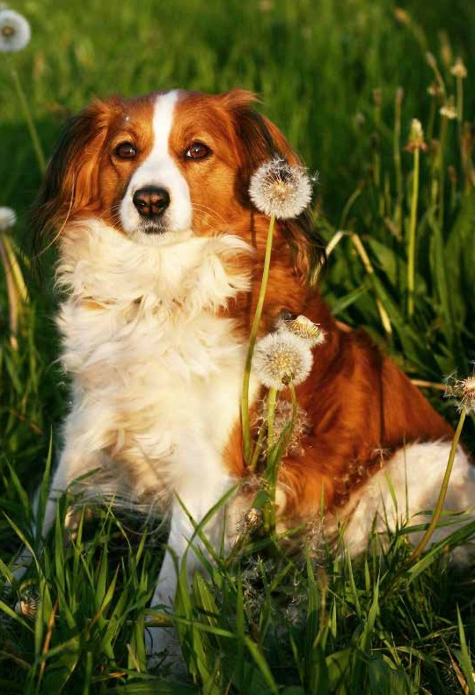

Kooikerhondje

**The Kooikerhondje is a Dutch breed stemming back to the 1500’s. They are also known as Dutch Decoy Dogs and were traditionally used to drive ducks into a trap where the hunter could easily get them. Their name comes from the hunter, who was called Kooi- ker. The dogs were called the Kooiker’s hondjes – the Kookier’s dogs – and this became the name of the breed.**

These dogs are known for being cheerful, well be- haved, friendly, and eager to please. They make great family dogs who adapt quickly and have the ability to change behavior from quiet to lively as the situation calls for it.

Since they are a hunting breed, they love outdoor life and need exercise to stay healthy and happy. They need a daily long walk or jog. Even though they can be happy in an apartment, they prefer a fenced in back- yard. Just like all working dogs, the Kooikerhondje gets bored easily, and they require stimulation. It’s much better to give them a task than allow them to make up some form of “work” of their own.

They usually reach a height of 14-16 inches, and can weigh up to 40 lbs. The average life span is 12-14 years.

Today, they’re often used as service dogs, and for search and rescue. They also excel at agility and obedi- ence. Kooikers are believed to be ancestors to the Nova Scotia Duck Tolling Retriever.

**Get a PlexiDor product catalog!**

### Visit: [www.plexidors.com](http://www.plexidors.com/) Call: 800-283-8045

Keeshond

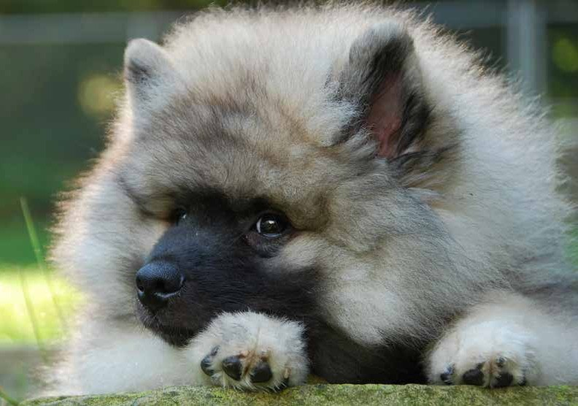

**The Keeshond is a medium-sized Dutch dog characterized by a lion-like ruff. It is a member of the spitz family of dogs, and descends from the same arctic strains as the Samoyed, Chow Chow, Norwegian Elkhound, Finnish Spitz, and Pomeranian.**

These dogs are generally playful with strong jumping ability and quick reflexes. They are quick to learn and eager to please, a combination that makes them excellent agility and obedience dogs.

Keeshonden get along well with children, and they like to be close to their humans whenever possible. While not aggres- sive to visitors they do announce newcomers loudly, and have been used as watch dogs through Europe.

The breed has a reputation for great empathy and are often used as comfort dogs. At least one Keeshond was at Ground Zero on 9/11 to help comfort rescue workers.

The average Keeshond weighs between 30 and 40 lbs, making the Medium PlexiDor dog door a perfect companion.

*“I purchased the PlexiDor small pet door for my Smitty Kitty and installed it in a basement window this summer. The cat finds it easy to use and my basement is still nice and warm. Here in Connecticut we have had some -10 wind chill days and no cold air comes through the cat door. Your pet door is a great product!”*

62 *V. Maloney – Connecticut*

**Norway has a characteristic and beautiful nature with many tall mountains and deep fjords. The country is also home to some dog breeds with unique traits, such as a dog with six toes on each foot.**

Amongst dog breeds stemming from Norway you will find the Black Norwegian Elkhound, the Halden Hound, Norwegian Buhund, and the Lundehund.

# Norway

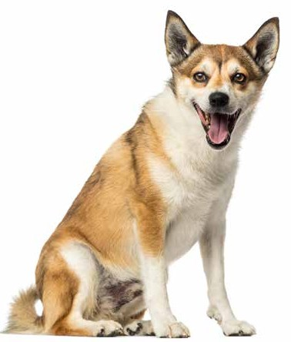

Norwegian Lundehund

**The Norwegian Lundehund is also called Norsk Lundehund or the “Puffin Dog.”**

It is a small and agile Spitz with several unique characteristics. It has six toes on each foot, prick ear that fold closed - back- wards or forwards at will - and a unique ability to tip its head backwards until it touches the back bone.

The head isn’t the only extremely agile part. The Lundehund has a great range of motion in all its joints, allowing it to fit into and get out of narrow passages. The extra toe makes it good at climbing.

The Lundehund is described in writing as far back as the 1500s, and originated in remote parts of Norway where it was used to wrestle and retrieve live Puffin birds from the crevices of steep vertical cliffs. The extra toe was particularly useful for these balance acts.

The breed was as good as extinct after the second world war, and all dogs alive today stem from five dogs found on a remote island in the Arctic Ocean. No other breed was ever on the island.

This is a loyal and playful companion with excellent personality. They are easy to live with and their coat require minimal upkeep. On the downside, the Lundehund has a digestive disorder that makes it difficult to absorb nutrients from food. In extreme cases, the dog can starve even though it is well fed.

**Get a PlexiDor product catalog!**

### Visit: [www.plexidors.com](http://www.plexidors.com/) Call: 800-283-8045

PlexiDor **Size Chart**

|  |  |  |  |  |
| --- | --- | --- | --- | --- |
| **Selecting Your Pet Door**  **Small Medium Large Extra Large** | | | | |
| **Size** | **Dog Weight** | **Opening Width** | **Opening Height** | **Breed Size Examples** |
| **Small** | Dogs up to **9** Cats up to **24** pounds | **6 1/2**  inches | **7 1/4**  inches | Cats, Chihuahuas, Pomeranians, Papillons, Yorkies, Maltese and Japanese Chins |
| **Medium** | Up to  **40**  pounds | **9**  inches | **12**  inches | Poodles, Corgis, Dachshunds, Beagles, Pekingese, Shelties, Schnauzers, Cocker Spaniels and most Terriers |
| **Large** | Up to  **100**  pounds | **11 3/4**  inches | **16**  inches | Labradors, German Shepherds, Golden Retrievers, Boxers, Collies, Setters, Bulldogs, Pointers and Dobermans |
| **Extra Large** | Up to  **220**  pounds | **16**  inches | **23 3/4**  inches | Great Danes, St. Bernards, Rottweilers, Old English Sheepdogs, Newfoundlands, Irish Wolfhounds and Great Pyrenees |
| **Electronic** | Up to  **125**  pounds | **12 3/4**  inches | **20**  inches | Large breed examples as listed including Malamutes, Weimaraners, Rhodesian Ridgebacks and all Cats |

**Installation Height The suggested mounting distance from frame to floor.**

These measurements are provided to help ensure a proper installation height based on the pet door size you have selected.

The distance shown is measured from the bottom of the frame to the floor.

Bottom edge of frame

Small

To floor

**2”- 4”**

Medium

**4”- 6”**

Large

**8”- 10”**

Extra Large

**12”- 14”**

64



**Measuring Your Dog**

Measuring your dog will help determine proper size and appropriate installation height.

Opening

Width

Opening

Height

Width Allow for 2” above

back height of pet

Back Height

The suggested measurements are a guide only. Make sure the pet door is installed so that the opening is at least 2” above the pet’s back.

**New Guinea represents less than one percent of the world’s landmass, but has an astonishing**

**number of animals and plants. The ecosystem has been isolated for long periods of time and shows an abundance of species found nowhere else in the world.**

This has also affected the island’s only dog breed; the New Guinea Singing Dog. The breed has devel- oped virtually undisturbed from the stone age until 1957 when the first dogs left the island.

# Papua New Guinea

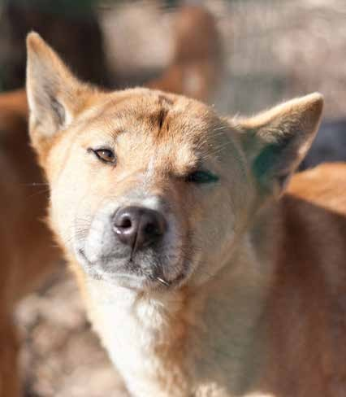

New Guinea Singing Dog

**The New Guinea Singing Dog isn’t your average house pet. The dogs are close to the wild with a strong hunting instinct. The breed is often called a living, breathing, four-legged fossil, and it is believed to be the rarest breed in the world.**

The name comes from their howl, which is melodious and distinctive. They can vary the pitch, and if howling in a group all dogs will strike a different pitch.

These dogs are intelligent, agile, graceful, lively, alert, and active. They can be quite stubborn, and they re- quire a lot of exercise to stay happy and healthy.

New Guinea Singing Dogs are escape artists not only able to jump and dig; they can climb trees too.

The Singing dogs are affectionate and gentle towards people they know, but uninterested in strangers. They also don’t see the point in performing for human enter- tainment, and they aren’t interested in learning tricks.

These dogs normally weigh between 18 and 30 pounds. They are hardy with an exptected life span of up to 20 years.

**Learn more about pet doors!**

**Visit** [**www.plexidors.com**](http://www.plexidors.com/)

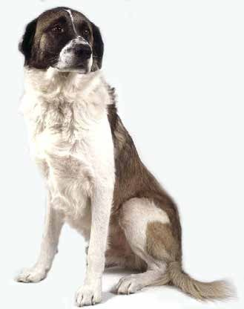

**Portugal has given the world around two handfuls of dog breeds, including the Estrela Mountain Dog, the Portuguese Pointer, and the Portuguese Water Dog, made famous in the USA by the Obama family bringing them to the White House.**



Portugal

do Alentejo

The Portuguese Water Dog is a working dog origi- nally developed to help fishermen. The dogs would herd fish into nets, retrieve broken nets, and act as couriers between ships and shore. They’re known for being loyal, active, and athletic. They have a water proof coat and are considered good for people with allergies.

Rafeiro

**The Rafeiro do Alentejo – also called the Alentejo Mastiff – is an old Portuguese dog breed developed to protect herds of sheep and cattle. The dogs are believed to stem from Molosser type dogs from Tibet that came to Europe thou- sands of years ago.**

These dogs are calm, self confident, and highly independent. They are affectionate with their family and will bravely protect the people, households, sheep, and cattle they perceive to be under their protection. They’re not aggressive, but protective, and they are particularly watchful during nighttime.

Puppies mature slowly and need to be watched when young; they don’t realize their limits and tend to overexert themselves with running, jump- ing, and climbing stairs. The breed is known to be suspicious against strangers, and it is wise to subject the puppies to many different environ- ments and people.

Being independent and bred to make decisions on their own, training a Rafeiro do Alentejo requires consistency and patience. They love affection and are eager to receive it, but won’t submit to a human’s every whim.

They don’t see the point in sitting, standing, sitting, lying down, sitting, high-fiving, and so on, and they prefer to save their energy for real work.

Besides the seasonal shedding period they require a minimum of groom- ing. They are generally calm indoors and don’t require excessive amounts of exercise, but should get a longer walk or a jog every day.

These are very large dogs that weigh up to 135 lbs, and they require an Extra Large PlexiDor Dog Door.

*“At the moment we have eight dogs, we’ve had as many as twelve here at one time. We installed the PlexiDor dog door unit in 2001 and it is still going strong. Our dogs are indoor-outdoor as they please, so you can imagine how many times the dogs have gone through the door during the years.”*

66 *P. Cahill and T. Brotherton*

Portuguese Podengo

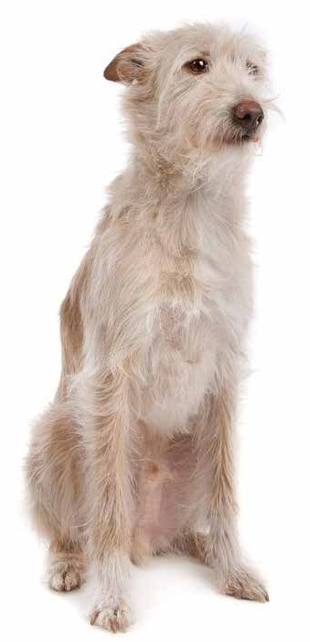

**The Portuguese Podengo is an ancient dog breed believed to stem from dogs brought to Portugal by Phoenician trad- ers around 700 BC. The dogs are hardy, intelligent, fearless, loyal, and energetic.**

The Portuguese Podengo has developed into three sizes: Pequeno, Medio, and Grande. Each size can be smooth or wire coated, and the different varieties are not interbred. They’re all referred to as the Portuguese Podengo.

Podengo Grande is the largest with a weight range of 44 to 66 lbs. They were originally developed for hunting deer and wild boar, and they are tough, hardy, and very observant. Nowa- days this size is rare, even in Portugal. A Portuguese Podengo Grande needs a Large PlexiDor dog door.

Podengo Medio weighs between 35 and 44 lbs. They are great at chasing, but can also stalk like a cat, and have a funny way of jumping to see over things. They are very active and make great dogs for active families. A smaller Podengo Medio can use a Medium PlexiDor dog door, but large individuals might need a Large PlexiDor dog door.

The Podengo Pequeno is the most common in the USA. They are watchful, observant, and very active. Many owners say these dogs are silly and funny indoors. Most Podengo Pequenos will require a Medium PlexiDor dog door.

The Portuguese Podengo is a hardy breed that often lives into its late teens. They excel at agility and other sports, and love to have a job to do.

**Get a PlexiDor product catalog!**

### Visit: [www.plexidors.com](http://www.plexidors.com/) Call: 800-283-8045

**Russia is a very large country, and the dog breeds stemming from Russia are as varied as the land- scape.**

Russia has given us the Samoyed, Siberian Husky, Russian Spaniel, Moscow Water Dog, Laika, Central Asian Shepherd Dog, Borzoi, Black Russian Terrier, and many more breeds.

# Russia

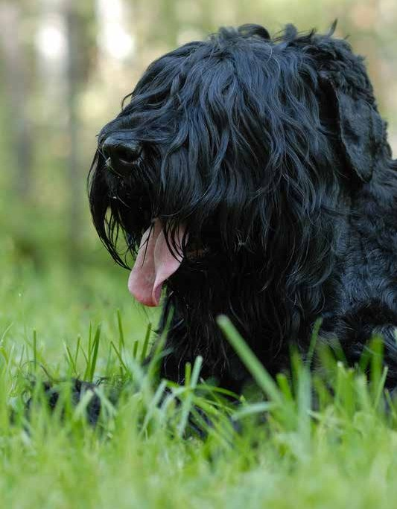

Black Russian Terrier

**The Black Russian Terrier is a large, powerful, and robust type of working dog developed in the Soviet Union after the second world war.**

When the war was over, the state operated Red Star Kennel, and the kennel’s task was to provide dogs to the Soviet Union’s armed services. The country needed large, strong, and unpretentious dogs that were also intelligent and easy to train. Furthermore, the dogs could not require exten- sive coat care.

There were few purebred dogs in the country at this time, and some breeds were imported to create a mix that could live up to the require-

ments. The Black Russian Terrier stems from a mix of Rottweilers, Giant Schnauzers, Airedale Terriers, and some other breeds.

Black Russian Terriers have a strong instinct to guard and protect. They are typically reserved with strangers but loving with the family. They have a great memory and learn new things with ease. Like all working breeds they need some- thing to do, and many Black Russian Terriers excel in agility and obedience.

The dogs are still rare outside of Russia, but they are gaining ground throughout Europe. They are very large - males usually weigh between 110 and 130 pounds, but can be bigger.

*“This new PlexiDor dog door is terrific! The rear of my house is no longer cold due to drafts, and it’s easy for my pets to use. Also, it looks much much nicer. This door is worth every penny. Thank you!”*

*J. Durst*

68

Borzoi

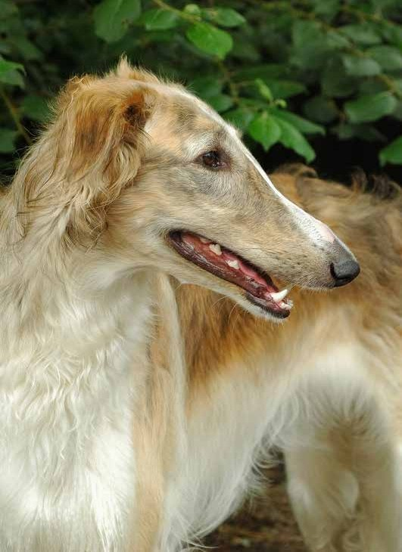

**The Borzoi is a large and elegant hound stemming from Russia where the aristocracy bred them for hundreds of years. There are records stemming back to the 13th century that describe hounds very much like the Borzoi, and the first breed standard was written in 1650.**

These dogs were often used for hunting wolves, and they are bred to be strong and quick enough

to be able to chase and capture a wolf. They are extremely fast and run between 35 and 40 mph.

When they’re not running, Borzoi are known for being calm and easy to get along with. They are quiet, affectionate, and indepen- dent.

Borzoi require regular exercise and grooming. Brush the coat every day, or at least every second day, and be prepared for seasonal shedding.

These are large dogs. Males often stand 28 inches or more at the shoulder, and weigh around 100 pounds. Despite the size they’re graceful and catlike indoors.

**Get a PlexiDor product catalog!**

### Visit: [www.plexidors.com](http://www.plexidors.com/) Call: 800-283-8045

Siberian Husky



70

*“The PlexiDor pet door is the best pet door. Moreover, it keeps out the winter wind and cold here on the northern plains. Wind up here often blows a steady 30-40 mph, but the door stays shut and the room remains warm. ”*

*S. Owen – North Dakota*

**The Siberian Husky is an energetic working breed that originated in north-eastern Siberia. They are clever and good with children, but require a lot of exercise and get bored quickly. Left to their own devices without anything to do, Huskies tend to make something up to entertain them.**

These dogs are active and resilient, and were originally bred to pull heavy loads over long distances in a harsh and cold climate. Huskies like to run, jump, and dig, and they need exercise every day.

The first Huskies come to North America were imported as sled dogs, but rapidly gained popularity as pets. They have a thicker coat than most breeds, and this serves them both in summer and in winter as the coat protects against arctic cold as well as reflects heat in the summer.

Siberian Huskies are pack dogs. That means they love being part of a family. They generally get along well with other dogs and they’re gentle with children, but they don’t like to be left alone.

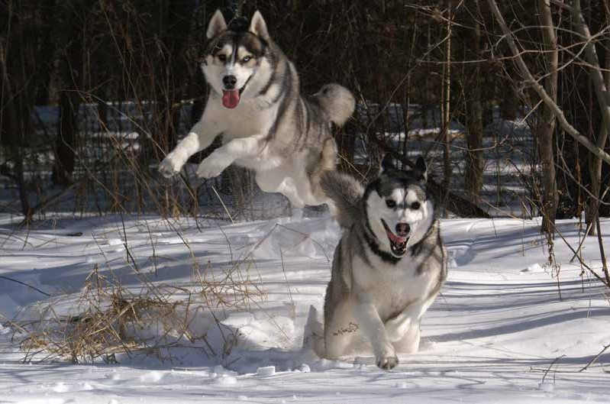

Samoyed

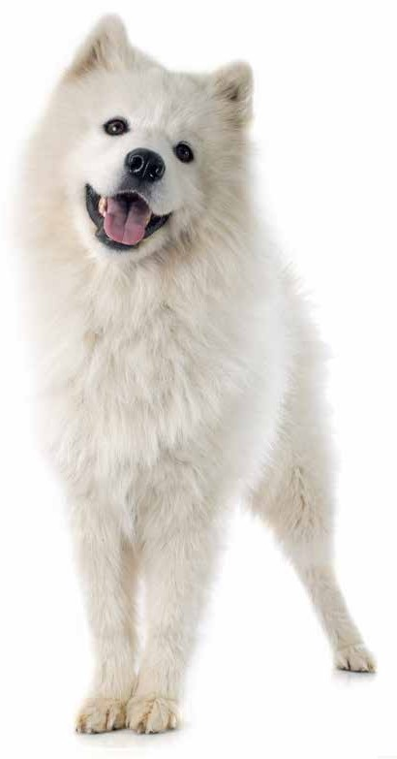

***There are fourteen ancient dog breeds currently identified through DNA analysis:***

***Afgan Hound Akita Inu***

***Alaskan Malamute Basenji***

***Chow Chow Lhasa Apso Pekingese***

***Saluki Samoyed Shar Pei Shiba Inu Shih Tzu***

***Siberian Husky Tibetan Terrier***

**Samoyeds are a friendly dog breed that has worked with everything from herding reindeer to pulling sleds. The breed gets its name from the nomadic Samoyedic peoples of Siberia.**

This breed is considered primitive. That doesn’t mean they’re not developed, it means they are one of the four- teen ancient breeds that have been identified through DNA analysis.

Samoyeds have a dense, double coat and they shed heavily twice each year. They shed a little all around the year, but during the seasonal shedding it’s snowing. Many use the shed fur for knitting, and the end result resembles angora. Samoyed fur sweaters can help a person withstand temperatures far below freezing.

These dogs are amongst the most friendly and sociable of all the spitz type dogs. They generally keep a happy ex- pression that has given them the nick-name “Smiley dog.”

Samoyeds can earn their keep as watchdogs because they will bark when something approaches, but they make poor guard dogs. They generally love children, and tend to herd them. A Samoyed playing with children will often attempt to keep them together and make them move in a new direction.

These dogs often compete in agility, carting, flyball, track- ing, mushing, and even herding.

**Learn more about pet doors!**

### Visit [www.plexidors.com](http://www.plexidors.com/)

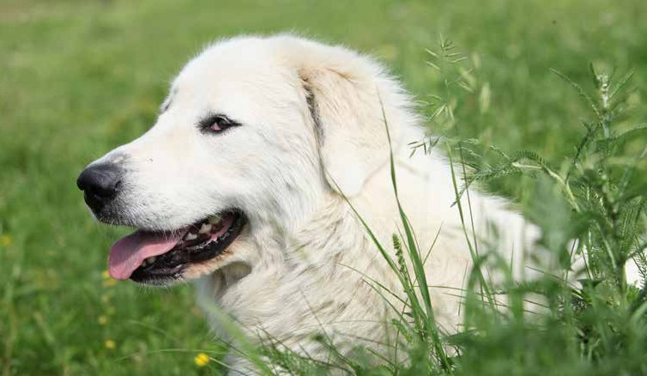

**There are around twenty dog breeds associated with Spain. The Great Pyrenees is probably the most famous, but other popular breeds include the Spanish Water Dog, the Pachon Navarro with its split nose, and the Burgos Pointer.**



Spain

Pyrenees

Other breeds from Spain include the Andalusian Hound, Catalan Sheepdog, Pyrenean Mastiff, and the Spanish Mastiff.

Great

**The Great Pyrenees is a majestic, confident, and smart mountain dog with waterproof coat and immense calm. The breed is believed to have come to Europe from central Asia around 1,000 BC.**

These dogs tend to work independently, and they might not always do what you tell them to do. They’re not amongst the most active of dogs, but they do need exercise to stay happy and healthy. They also need weekly brushing to keep the coat in good condition.

While these dogs are known for being calm and friendly, they are also very big. It is wise to enroll in puppy school and teach the dog good manners from a young age, just to make sure you’re walking the dog and not the other way around.

*“I’ve had one of your Extra Large PlexiDors for several years, and I love it. I’ve had several other cheaper doors over the years, and this door is absolutely worth every penny. In fact, I just this morn- ing recommended it to my boss who is looking for a dog door. Thank you for a great product!”*

*L. Mills*

72

**Sweden is a large country to the surface, but with a fairly small population. The fact that the Scandi- navian peninsula *is* a peninsula has benefited the development of unique dog breeds in the Nordic countries.**

Amongst the Swedish breeds you will find the Drever, Hamilton Hound, Swedish Vallhund, Swedish Lapphund, and several other breeds.

# Sweden

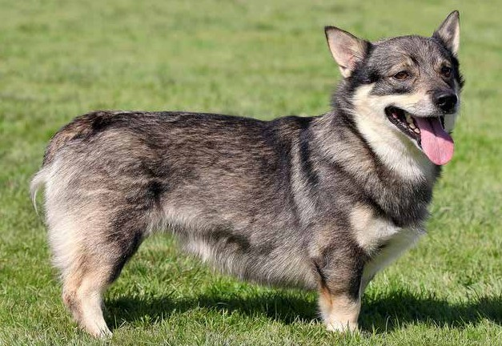

The Vallhund has been featured on stamps around the world. Besides Swedish stamps the breed has been on stamps from

Nicaragua, Ukraine, Mali, and Russia.

These dogs normally weigh between 20 and 30 pounds and stand between 11.5 and 13.5 inches at the shoulder. A medium PlexiDor dog door is perfect for letting them into the yard.

**Get a PlexiDor product catalog!**

**Visit:** [**www.plexidors.com**](http://www.plexidors.com/) **Call: 800-283-8045**

Swedish Vallhund

**The Swedish Vallhund is often referred to as the dog of the Vikings. In Sweden the breed is called Västgötaspets. This is a small, sturdy, and fearless dog that stems back to the Vikings over 1,000 years ago. Some historians believe they were brought to Wales around the year 800, forming part of the ancestry of the Welsch Corgi.**

The Swedish Vallhund is an original species, and this means it didn’t come from another type of dog. They are traditionally used to herd cattle, catch vermin, and guard the home. Today they excel at obedience, agility, tracking, herding, and flyball. They’re intelligent, alert, and eager to please at the same time as they are athletic and active.

In Sweden, docking of the tail is against the law, but some Vallhunds are still seen with bobtails. They can be born with no tail, with a stub tail, or with full tail.

Norrbottenspets

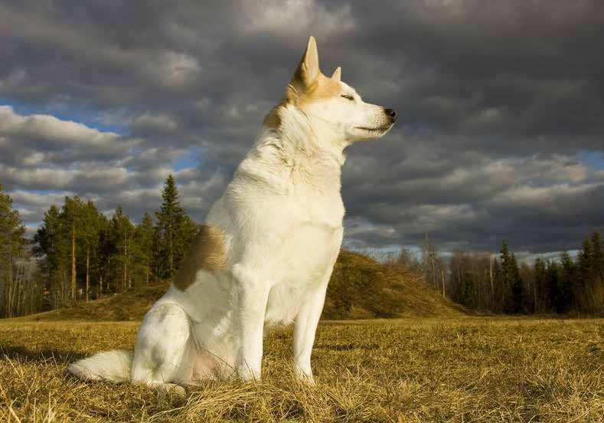

**Norrbottenspets is an ancient Swedish dog breed also known as the Nordic Spitz. They were originally used as farming and hunting dogs, but they are adaptable and can be trained for any sport or competition.**

The oldest known written documentation of the breed stems back to the 17th century, but it is likely they were around even earlier. They are popular for hunting grouse and fox, but some dogs with tousle with animals as large as moose and bear.

These dogs are intelligent, strong, and fast. They’re normally good with children, cats, and other pets belonging to the fami- ly, but they have a strong prey drive and should not be let off leash in an unfenced area.

The Norrbottenspets is a hardy breed. They are considered the healthiest breed in their home country of Sweden based on statistics from insurance companies and veterinarians. They are also ranked as having the third longest life span of all breeds common in Sweden.

A Norrbottenspets normally weighs between 20 and 30 pounds, making the medium PlexiDor dog door a perfect match.

*“This is our second order of PlexiDor (new house) – we are very pleased with the products and installation support.”*

*C. Smalley – Pennsylvania*

74

Danish Swedish Farmdog

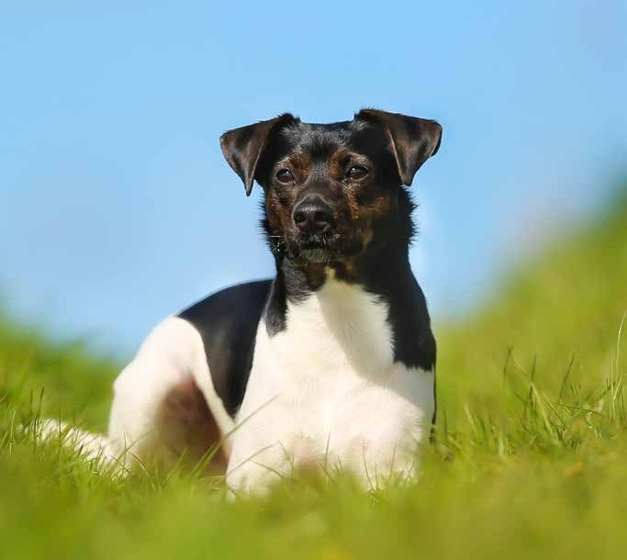

**The Danish Swedish Farmdog comes from the area of southern Sweden and northern Denmark. The dogs historically worked on farms as multipurpose dogs that caught vermin, hunted, and protected farms and animals.**

These dogs are known for being gentle, soft, and easygoing. They make great family dogs and normally do very well with children. As most working breeds, they have an abundance of energy and love having a job to do. They do well in active dogsports such as agility, flyball and lure courseing.

Many think this is a type of terrier, but these dogs have a quite different temperament than the average terrier. They are energetic enough to be good at their job, but also able to relax.

A Danish Swedish Farmdog weighs between 15 and 25 pounds, and needs a medium PlexiDor dog door.

**Get a PlexiDor product catalog!**

### Visit: [www.plexidors.com](http://www.plexidors.com/) Call: 800-283-8045

**Switzerland is a small country to the surface, but big when it comes to producing world popular dog breeds. The St. Bernard is probably the most well known, but several other breeds also come from this area.**

The Swiss Mountain Dogs include the Greater Swiss Mountain Dog, Bernese Mountain Dog, Appenzeller Sennenhund, and the Entlebucher Mountain Dog. Other Swiss breeds include the Alpine Spaniel and the Berger Blanc Suisse.

# Switzerland

St. Bernard

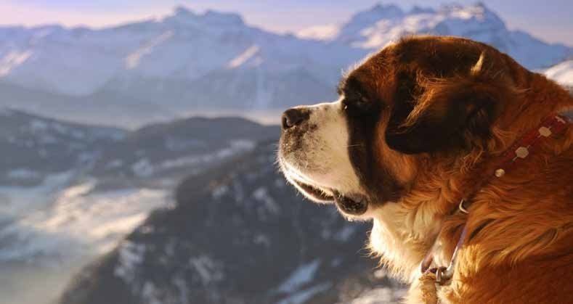

**The St. Bernard is probably most associated with rescue dogs carrying a keg around the neck, and the dogs were indeed used for rescue missions in the Swiss Alps. The earliest written records stem back to 1707, and there are even older paintings depicting the dogs.**

In the early 19th century the breed was nearly extinct, and in an effort to save it the remaining dogs were bred with New- foundlands. This cross breeding changed the build of the dogs and gave them a much longer coat than they originally had, which prevented them fron successfully rescuing people in the mountains.

These dogs are friendly and loyal, but with an average weight between 140 and 160 pounds, training is vital.

*“We purchased one of your awesome PlexiDor dog doors last year and my husband installed it by himself in one day. It was the best thing we could ever have done.”*

*P. and R. Wagner*

76

Appenzeller Sennenhund

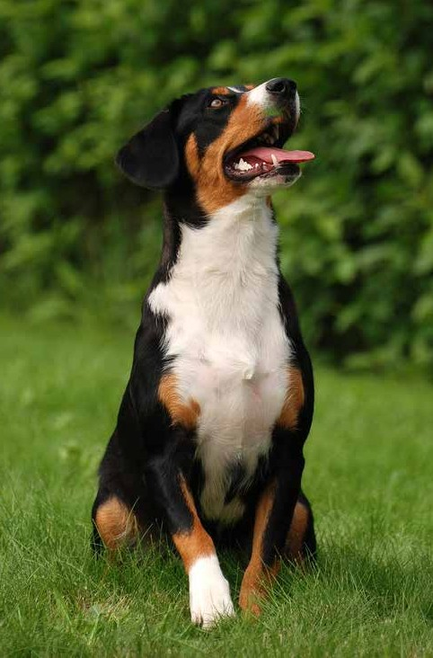

**The Appenzeller Sennenhund is the rarest of the Swiss Mountain dogs. It belongs to the same category as the more known Bernese Mountain dog, but they are separate breeds.**

This is a large and active breed that requires exercise, training, and a job to do. Due to their size and high energy level they’re not ideal for apartment life. They bond closely with their owners and thrive on attention, but can be suspicious toward strangers. They do, however, nor- mally get along well with other dogs and other types of animals.

Appenzellers are generally affectionate and charming, intelligent, tough, and energetic. They learn quickly and love having something to do.

They are often used to herd cows, and control wayward cows through dashing in to nip at the heels. This requires cour- age and says a lot about the breed. They also excel at agility and games of catch.

Most Appenzellers are healthy, and the average life span is 13-17 years. They weigh between 50 and 70 pounds and require a large PlexiDor dog door.

**Learn more about pet doors!**

### Visit [www.plexidors.com](http://www.plexidors.com/)

White Swiss Shepherd

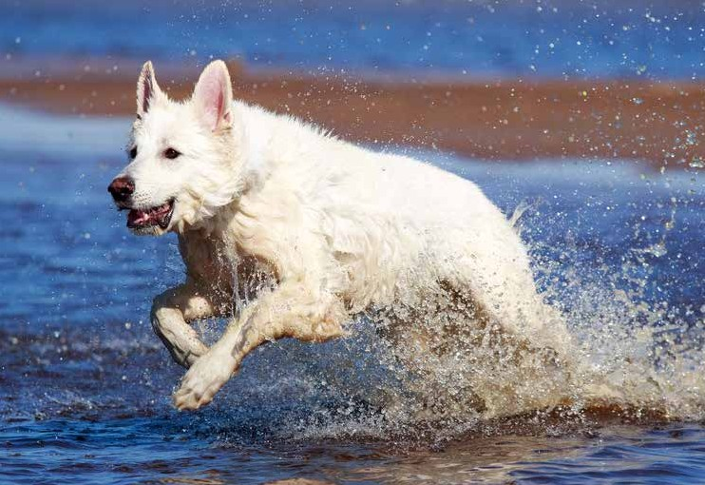

**The White Swiss Shepherd, or Berger Blanc Suisse, is an intelligent and loyal dog with cheerful temperament. They are friendly and eager to learn, and make great family dogs as well as working companions. The average White Swiss Shepherd is very good with children, attentive, and curious.**

The dogs are related to the German Shepherd, and the breed emerged from white coated German Shepherds. Switzerland was the first country to officially recognize the dogs as a separate breed, thus the name.

White Swiss Shepherds are gentle and normally get along well with other dogs. They are often used for search and rescue, agility, and obedience, and make great assistance dog. While they are both willing and able to protect their family they’re not usually used as guard dogs. Unless someone they love is threatened they’re generally too gentle and mellow to bother with strangers.

Like all working breeds, they are happiest if they get ample exercise and something to do.

*“Have loved my PlexiDor for 15 years! Thank you for such a good product!”*

*Preppy Jennings – Greenville, NC*

78

Bernese Mountain Dog

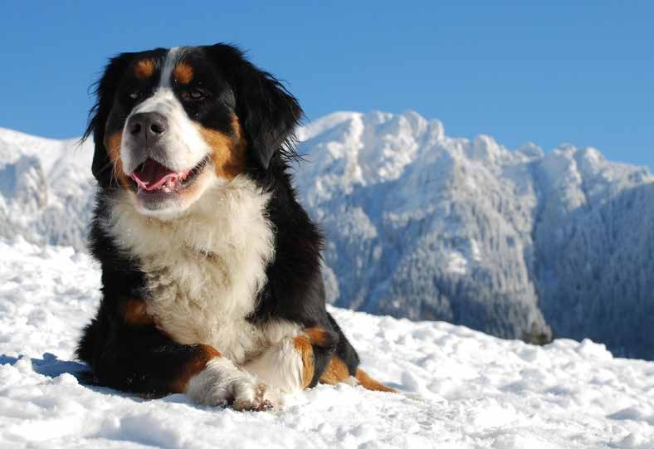

**The Bernese Mountain Dog is the only one of the Swiss Mountain Dogs with a long and silky coat. In addition, it is probably the most known of the breeds in the group.**

Bernese Mountain Dogs are smart, strong, and agile, and were historically developed as farm dogs. They worked cattle and watched over the farm. Today, they excel at agility, tracking, herding, obedience, and therapy work.

Bernese Mountain Dogs are known for being good natured, self assured, and friendly. They require a lot of exercise and can move much faster than most people expect when seeing a dog this size. Bernese Mountain Dogs have a gentle and easy going manner, and they love to be close to their family. They’re usually patient and affectionate and do well with children.

**Get a PlexiDor product catalog!**

### Visit: [www.plexidors.com](http://www.plexidors.com/) Call: 800-283-8045

**Many popular dog breeds come from England or other parts of the United Kingdom. Several are working breeds, but many are also bred for company.**

Many spaniels, hounds, and terriers come from this area. Examples of common dog breeds include the Beagle, Jack Russell Terrier, Bloodhound, Old English Sheepdog, Border Collie, Border Terrier, Cavalier King Charles Spaniel, and the English Setter.

# United Kingdom

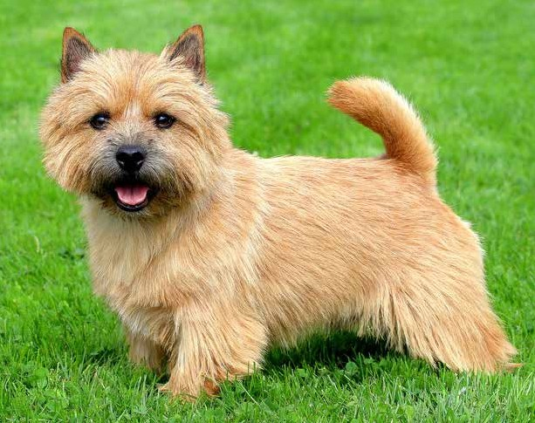

Norwich Terrier

**The Norwich Terrier is an intelligent and energetic working dog from England. This is basically the same breed as the Norfolk Terrier – the difference between the breeds can be seen in the ears. A Norwich terrier has perked, upright ears while a Norfolk Terrier has dropped ears. The two varieties were considered one breed for a long time.**

Norwich Terriers were originally created to hunt small vermin and foxes, and the strong hunting instinct remains in the breed. Even the most well behaved Norwich Terrier can succumb to instinct and take off after a squirrel or other animal considered prey, and it is wise to not let them off leash outside a fenced in yard.

These dogs love their families. They’re adaptable, eager to please, and generally get along well with children. They do need ample exercise – at least two long and brisk walks every day – and they’re happiest when they have something to do. If your Norwich terrier barks a lot or digs a lot of holes in the yard he or she is probably bored.

When it comes to grooming they need a weekly brushing. Most owners strip the coat twice a year

* stripping means to pull out the dead top coat
* and doing so maintains the dog’s characteristic appearance and gets rid of a lot of the shedding. They don’t need frequent baths, unless they find something stinky to roll in, of course.

The Norwich Terrier is one of the smallest terriers. They generally stand around 10 inches tall at the shoulder and weigh around 12 lbs. A small indi- vidual can get by with a small PlexiDor dog door, but most Norwich Terriers will need a medium PlexiDor dog door.

*“I have 5 big dogs, Mastiffs and Bull Mastiffs, and have used the Plexidor XL dog door for 15 years now. The constant use of this dog door by these dogs is proof of their value. And, the technical support is terrific.”*

*J. West – Granite Falls, WA*

80

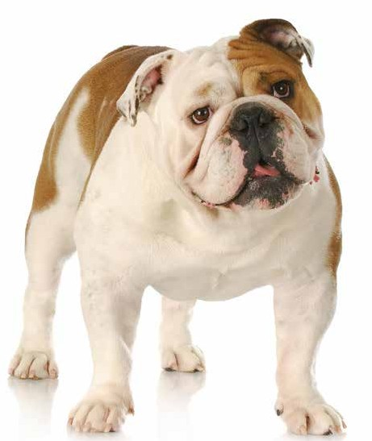

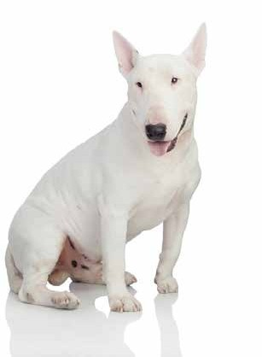Bull Terrier

**Many who don’t know the breed fear bull terriers because of their muscular appearance and unusual head shape. This is one of the world’s friendliest dog breeds, created in the 1800s to be companions that combine the best of bulldogs and terriers.**

Bull Terriers love to play. They thrive on affection and are often referred to as clowns. They can be quite goofy and become attached to their families - they don’t like being alone. They are energetic and need exercise. For those who like to

compete, many Bull Terriers do great in obedience, agility, and show rings.

English Bulldog

**The English Bulldog is a friendly and patient dog known for getting along well with children, other dogs, and other types of pets. These dogs are muscular and heavy and some find their appearance intimidating, but they’re normally absolute sweethearts and amongst the gentlest of all dog breeds.**

Bulldogs are calm dogs that like to relax in a comfortable chair and watch TV with their humans. They need a walk every day, but they’re far from the explosive bundles of energy characteristic for many other dog breeds.

Take care with bulldogs during summer - they are sensi- tive to heat and must be protected so they don’t get heat stroke. Also watch over your bulldog when you’re close to water. Most bulldogs are unable to swim and will sink no matter how much they paddle to stay afloat.

English Bulldogs are known for being gentle, loving, de- pendable, and protective. They are likely to form strong bonds with children. They seek out human affection and attention.

An English Bulldog normally weighs between 53 and 55 pounds, and needs a large PlexiDor dog door.

**Get a PlexiDor product catalog!**

### Visit: [www.plexidors.com](http://www.plexidors.com/) Call: 800-283-8045

Border Collie

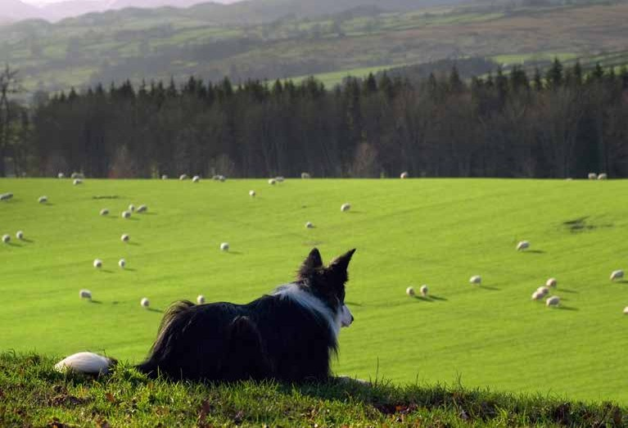

**The Border Collie is a herding dog from the United Kingdom. These dogs are intelligent, energetic, acrobatic, and ath- letic. They are often referred to as the smartest of dogs, Einsteins of the dog world, race cars on paws, and workaholics of the dog world.**

Many Border Collies appear in TV shows, movies, and commercials. In 2013 one Border Collie was tested on over 1,000 words along with basic understanding of grammar, and Swedish movie dog Turbo understood three languages. They can run around 30 mph and maintain speed while they twist and turn with full control.

This is a fantastic dog for the right owner, but they need interaction, constant stimulation, and something to do. Deprived of this they grow bored and make up chores for themselves - which usually includes something you don’t want your dog to do.

Border Collies also tend to herd anything that moves, including children, bikes, cars, other dogs, and other animals.

*“I had a PlexiDor dog door for eight years. My collie and chow RAN through that door a hundred times a day and it never failed. The wall unit is still in that house, now a rental. This house came with a flap and my two fast and loving pit bull mixes deserve better. Time for a new PlexiDor, this will be the third unit I have installed.”*

82 *Rich Braverman – Las Vegas, Nevada*

Golden Retriever

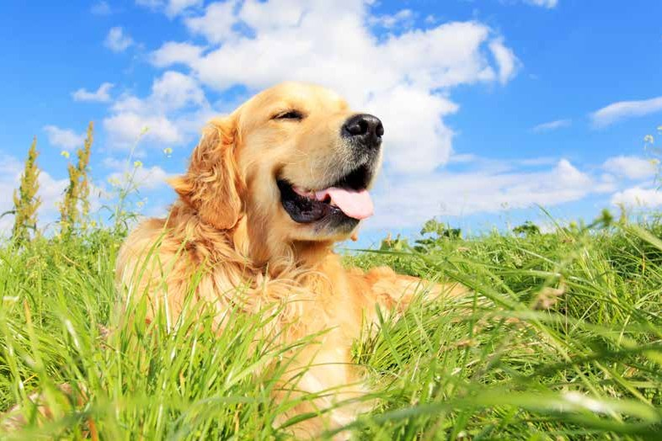

**The Golden Retriever is one of the most popular breeds in the USA and around the world. These dogs are intelligent, eager to please, and hard workers – a combination that makes them perfect guide dogs, assistance dogs, and search and rescue dogs.**

Golden Retrievers stem from Scotland, where the breed was created as a hunting companion well suited for the climate and terrain. The breed as we know it today took shape in the late 1800s. They’re generally good at whatever they do, and take tasks seriously.

These dogs are active and energetic, and they require daily exercise. Golden Retrievers have a joyful approach to life, and they love to be part of an active family that takes them hiking, jogging, and lets them play every day.

An average Golden Retriever weighs between 55 and 75 lbs, and needs a Large PlexiDor dog door.

**Learn more about pet doors!**

### Visit [www.plexidors.com](http://www.plexidors.com/)

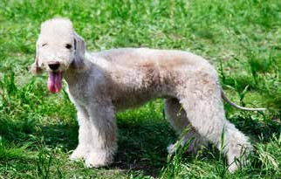Bedlington Terrier

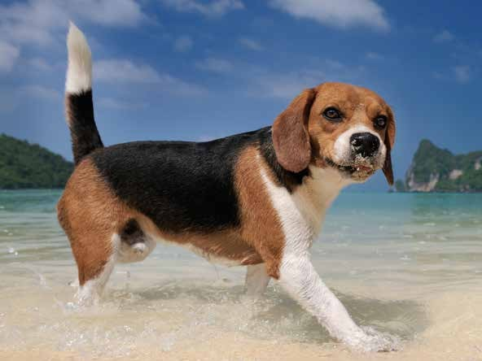

**The Bedlington Terrier was developed in England in the early 19th century. The dogs were used to take care of vermin in the Bedlington Mining Shire, and they get their name from the area.**

This breed generally does very well with children and the dogs are known to be mild and gentle with their family. It is important to teach them good recall; they run extremely fast, and it is not a good idea to let them off leash unless in a securely enclosed area.

Bedlington Terriers can get along fine with other household animals, but they were bred to be hunters and it’s a good idea to get them accustomed to living with other pets at a young age. Despite their small size they have been used to hunt both badgers and foxes, and the strong hunting instinct remains.

When it comes to care and grooming, the Bedlington sheds little to no hair, but needs trimming every six weeks. Despite some hereditary diseases such as a liver problems, their average life expectancy is still around 17 years.

The Bedlington Terrier is small, usually between 18 and 23 pounds, and does well with a medium PlexiDor dog door.

Beagle

**The Beagle is a sturdy hunting dog with cheerful personality. They are friendly, merry, enjoy the company of both humans and other dogs, and they make great family pets. They also have one of the best developed senses of smell of any dog.**

Beagle-type dogs have existed for at least 2,000 years, but the modern breed comes from Great Britain where it was developed around 1830. They’re popular in film, TV, and comic books, and Snoopy is no doubt the most famous beagle.

This breed is easy to care for. They don’t drool, they don’t “smell like dog” and they shed little.

Beagles are generally healthy and have an expected life span of 12-15 years.

Beagles weigh between 20 and 25 lbs, and do well with a Medium PlexiDor Dog Door.

*“This dog door has singlehandedly changed my life. I have so much more freedom, I basically feel like I have a full time caretaker for my dog. In addition to being an incredibly well made and designed product, the PlexiDor customer service has been beyond my expectations.”*

*Ryan McMurtrie – Winneconne, Wisconsin*

84

**Well over fifty dog breeds are associated with the USA, and many of these breeds have become popular around the world.**

Examples of dog breeds from the USA include the American Bulldog, American Foxhound, Mountain Cur, American Pit Bull Terrier, Toy Fox Terrier, Blue Lacy - which is the state dog of Texas - and the Black Mouth Cur.

# USA

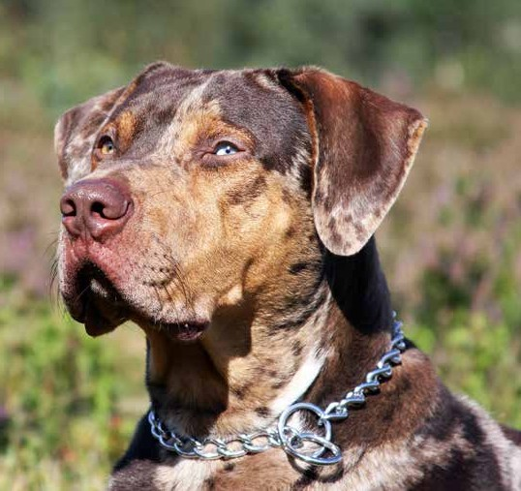

Catahoula Cur

**The Catahoula’s official name is Louisiana Catahoula Leopard Dog, and it is believed to be the first dog breed devel- oped in North America. The breed is named after Catahoula Parish in Louisiana, and they are Louisiana’s state dog.**

The Catahoula is an energetic and highly intelligent dog. They like to have a designated job to do, and that job will be taken seriously. Catahoulas make outstanding hunting dogs able to track animals from miles away, and they are often used for herding cattle. They also make won-

derful family dogs, as long as they’re allowed to be with the family - they don’t like being left alone in a yard.

Catahoulas are protective and will alert to anything out of the ordinary. They are assertive, but not aggressive.

These dogs have been bred more based on ability than appearance, and come in a wide range of colors and sizes.

They typically weigh between 40 and 90 pounds, which would make a large PlexiDor dog door a great choice, but some large individuals weigh 110 pounds and would require an extra large PlexiDor.

**Get a PlexiDor product catalog!**

### Visit: [www.plexidors.com](http://www.plexidors.com/) Call: 800-283-8045

Alaskan Malamute

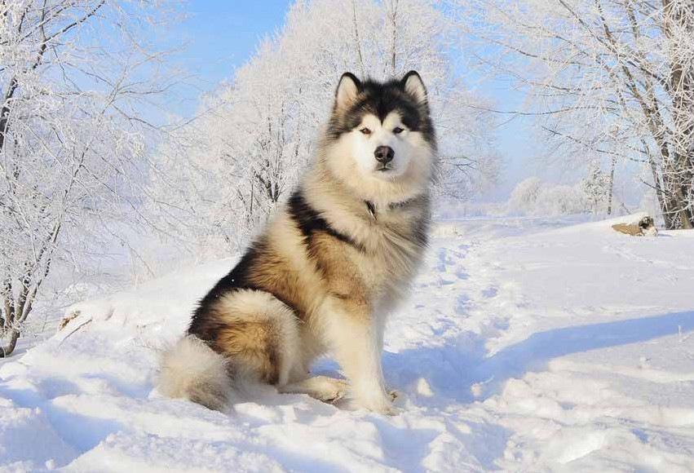

**The Alaskan Malamute is the largest and oldest of the Arctic sled dogs. They have a quiet and dignified temperament and are known for their unwavering loyalty to their owners.**

This is an arctic breed developed to carry large loads over long distances, and they love activity. Alaskan Malamutes are known for their power and endurance, and they enjoy sledding, back-packing, jogging, and swimming.

The dogs are brown eyed and heavy with a double coat. The undercoat can be up to two inches long, protecting the dog from cold, snow, and harsh weather. The dogs are affectionate, friendly, and intelligent, but can be stubborn.

Average height is 23-25 inches and acerage weight 75-85 pounds, making a large PlexiDor dog door a perfect fit. Some individuals can be very big and weigh well over 100 pounds, and they would need an extra large PlexiDor.

*“I have five big dogs, Mastiffs and Bull Mastiffs, and have used the Plexidor XL dog door for 15 years now. The constant use of this dog door by these dogs is proof of their value. And the technical support is terrific.”*

*John West – Granite Falls, Washington*

86

**PlexiDor**® **Awning**

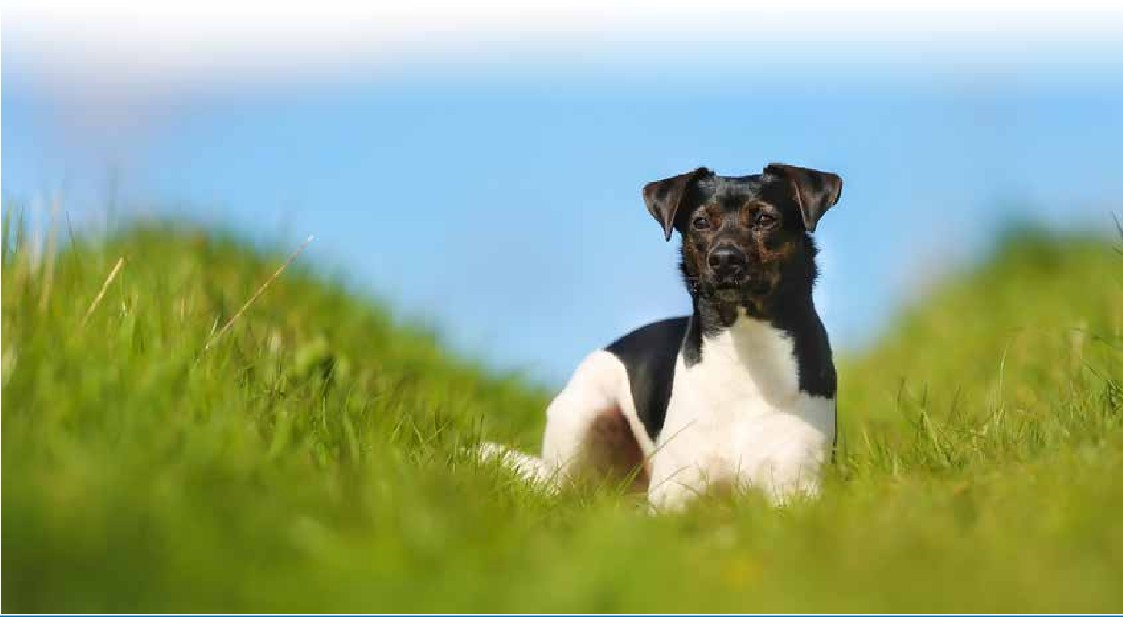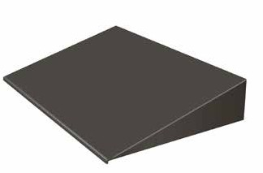

#### Stop Snow, Rain, and Sun!

**The easy to install PlexiDor® Awning prevents rain, sun, and snow from entering through a pet door.**

The pet door awnings are made from durable aluminum with a baked-on finish. They are available in white or bronze, and make a perfect accessory for all PlexiDor® pet doors. Available in three sizes

.

*Not designed for installation on glass.*

##### *Don’t let snow or rain come in when your* pet goes out!

##### *Reduce the wind on your pet door*

##### *Reduce energy loss*

*“Your company has outstanding customer service and friendly, knowledgeable staff. I just wanted to write to you and tell you how much I love your doors, and how happy they make both me and my best friends.”*

*Merry LoCurto*

**Danish Swedish Farmdog See Page 75**

**Get a PlexiDor product catalog!**

### Visit: [www.plexidors.com](http://www.plexidors.com/) Call: 800-283-8045

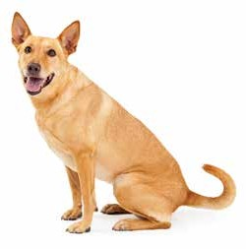Carolina Dog

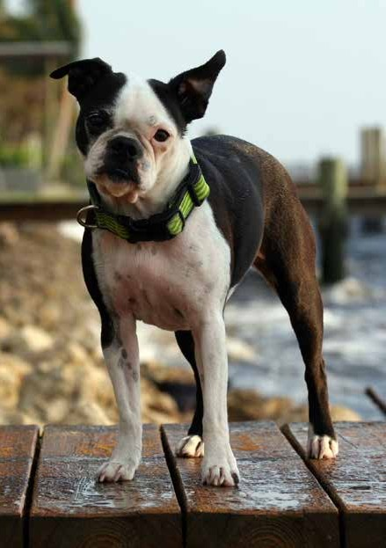

**The Carolina Dog was first discovered in the 1970s and it is a landrace, which means it has developed by natural processes and adapting to its environment. The Carolina Dog is one of very few breeds that developed to survive in nature and not through selective breeding.**

These dogs are likely to be relatives to the first dogs that crossed the Bering landbridge into America from Asia together with the first primitive humans. There are skulls and fossils over 2,000 years old that are nearly identical with the Carolina Dog of today.

Many of these dogs are shy around people, but when kept as pets they are loyal to their human and bond with the family’s children. They are gentle and social, and integrate well with the family.

Boston Terrier

**The Boston Terrier is a small and compact dog often nicknamed the American Gentleman. These dogs are known for being friendly and quiet, and they have a happy-go-lucky personality.**

The breed originated in Boston just after the Civil War, and is a result of crossing English Bulldogs with white English Terriers. Most modern Boston Terriers can be traced back to one single ancestor; a dog known as Hooper’s Judge.

Boston Terriers are intelligent and easy to train. Many do very well in obedience, as therapy dogs, and in agility or flyball competitions.

The Boston Terrier is well suited for being a compan- ion and house pet. They require moderate amounts of exercise and a minimum of grooming. They thrive on attention and human contact.

The average weight span ranges from 10 to 25 pounds, and the dogs need a medium PlexiDor dog door.

*“My wife and I own three Leonbergers and three Chinooks. We were constantly replacing flaps or panels. Then we installed two PlexiDor XL units at our new home. They have functioned flaw- lessly and allow our pets 24 hour access to their yard. We are very satisfied that we invested in a superior product.”*

88 *Rick Skoglund – Waldboro, Maine*

Australian Shepherd

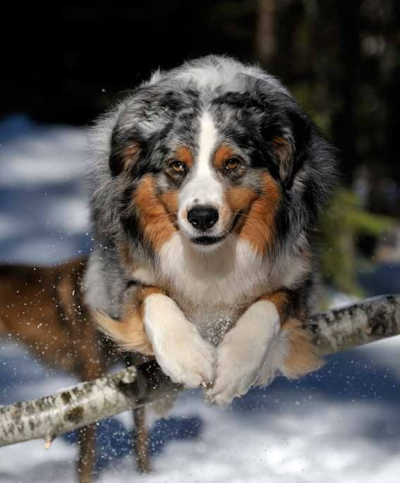

**The Australian Shepherd - or Aussie - is not an Australian dog breed; they get their name from herding Australian sheep. The breed is believed to have originated on farms in the western United States.**

Aussies come in a wide range of color combinations, and their eye colors vary to the point where the breed has been nicknamed the ghost eye dog. Their eyes can be any shade of brown or blue - or split with half of an eye brown and the other half blue.

Some Aussies are born with a naturally bobbed tail. Others have full long tails, and others yet natural partial bobs.

Not many dog breeds smile like humans do, through baring their teeth, but the Aussies are known for doing this.

Like all working breeds, the Aussies have a lot of energy and need a job to do. They are often used as search-

and-rescue dogs, disaster dogs, guide, service, or therapy dogs. They also excel at agility, flyball, and frisbee.

The dogs are known for being clever, energetic, kind, loving, and devoted to their family.

Aussies can come in many sizes, and fall somewhere in the range of 30 to 65 pounds. Most Aussies will require a large PlexiDor dog door, but smaller

individuals can do well with a medium PlexiDor.

**Learn more about pet doors!**

### Visit [www.plexidors.com](http://www.plexidors.com/)

Rat Terrier

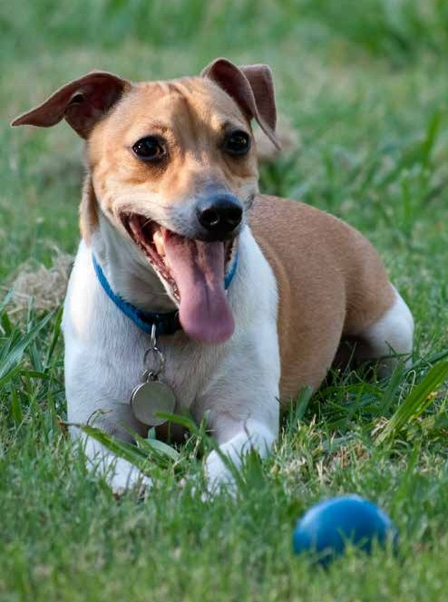

**The Rat Terrier is an American dog breed that used to be common on family farms throughout the USA. In the past they were used as farm dogs and hunting companions, but today they’re considered a rare breed.**

Rat Terriers come in a variety of coat colors and patterns and are often mistaken for Jack Russells. They are intelligent and active dogs who make wonderful family pets.

The name comes from the occupation of its earliest ancestors who arrived to the USA in the 16th century; they were used for controlling vermin and hunting small game.

During the years they have been bred for speed and working abilities, and this history distin- guishes them from many other types of dogs. In many cases a breed developed from a small number of founding dogs, but the Rat Terrier stems from a large number of breeds and bene- fits from genetic diversity.

These dogs have a definite terrier personality, but they’re usually calmer than Jack Russells, and they love lounging on the sofa almost as much as zooming around the yard.

They are known for being sensitive, easy to train, and healthy. Like all active and intelligent breeds they require company and stimulation.

Rat Terriers shed seasonally, but besides some extra brushing at those times, they don’t require excessive grooming. A weekly brushing and an occasional bath go a long way towards keeping the Rat Terrier looking great.

This is a fairly small dog, usually between 10 and 25 lbs, and they do well with a medium PlexiDor dog door.

*“The PlexiDor Electronic pet door works wonders! Absolutely worth every penny!”*

*Barbara Graham – Oregon, IL*

90

American Cocker Spaniel

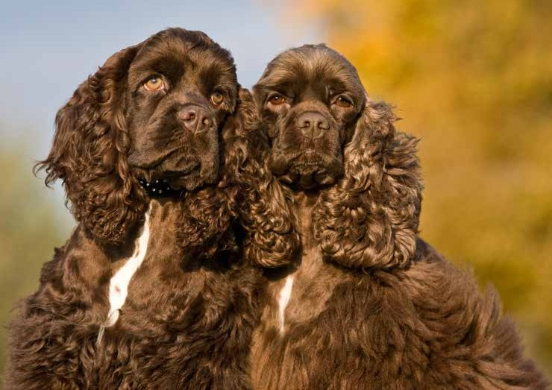

**The American Cocker Spaniel is one of the most popular breeds in North America. They are cheerful and generally get along well with children, other dogs, and other types of pets.**

The history of the Spaniel goes back to the 14th century, and the first one in America is believed to have arrived on the Mayflower in 1620. Since then the American Cocker Spaniel has developed individually, and grown quite different from its English relatives.

The breed is sturdy, good natured, clever, and well balanced. They usually get along well with children and pets of all kinds. Despite being so small, they possess both speed and endurance. These dogs are often described as the “can-do” dog that makes a great family companion.

When it comes to grooming, this breed has an abundance of hair and they require regular grooming. On the bright side, brushing your dog is a great opportunity to bond.

A typical American Cocker Spaniel weighs between 24 and 30 pounds, and would require a medium PlexiDor dog door.

**Get a PlexiDor product catalog!**

### Visit: [www.plexidors.com](http://www.plexidors.com/) Call: 800-283-8045

Rhodesian Ridgeback

# Zimbabwe

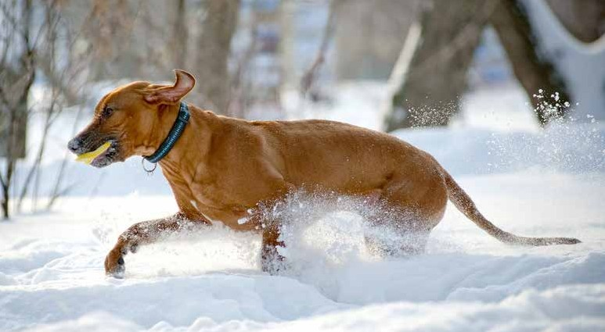

*“The PlexiDor dog door is the greatest thing, it really is. It frees you and your dogs, and you will experience very little heat loss.”*

*Eva Kaufman – Ontario, Canada*

92

**The Rhodesian Ridgeback is a large and muscular dog developed for hunting lions and protecting the family. They are large and tough enough to corner a wild African lion, while also fast enough to compete with Greyhounds. The name Rhodesian Ridgeback comes from a ridge of hair down the back that grows the opposite way from the rest of the coat.**

The breed was developed during the 1600s when European settlers in Africa bred their dogs with native African dogs. As time went by, Great Dane, Mastiffs, Greyhounds, Terriers, and other breeds were mixed in. This ended in 1707 when Europe- an immigration was closed for a hundred years, and during this time the native dogs got a bigger portion of the mix.

Rhodesian Ridgebacks are known for being independent and strong-willed, but they are also loyal, gentle, and reliable. They love to be with their family, preferably curled up on the couch. The breed was created to be versatile, and the dogs have worked as big game hunters, watchdogs, and even herders.

A Rhodesian Ridgeback generally weighs between 70 and 85 pounds, and needs a large PlexiDor dog door.

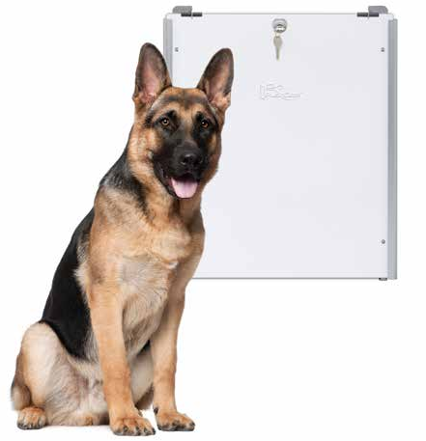

**Sliding tracks with flip lock**

#### Secure your home with ease and convenience!

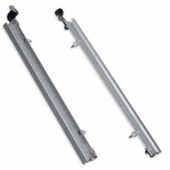**Whether you leave your home for an extended period, or want added safety every day, the PlexiDor® sliding track accessory makes securing your home a breeze.**

PlexiDors® size medium, large, and extra large are delivered with a steel security plate that screws onto the pet door frame. The plate is a great tool for securing the home, and for signaling to pets that the door is locked. Using the sliding tracks, it takes seconds to mount the plate.

The tracks attach to the dog door’s interior frame using just a screw driver, and the security plate slides down to its optimal position. Fasten the plate with the handy flip lock, and it’s done.

The tracks are made from strong and durable aluminum that matches the pet door frame. They are available in silver, white, or bronze, in sizes medium, large, or extra large. The smallest door does not have a security plate, because it is too small for a person to get through.

Hardware for track installation is included.

##### *Secure your home with ease*

##### *Tell your pets the door is locked*

##### *Easy installation*

##### *Call 800-283-8045!*

**Learn more about pet doors!**

### Visit [www.plexidors.com](http://www.plexidors.com/)

Dog Breeds of the World

## *Breeds represented in the book*

Afghan Hound 6

Aidi 60

Akita 55

Alaskan Malamute 86

American Cocker Spaniel 91

American Eskimo 34

Appenzeller Sennenhund 77

Australian Cattle Dog 7

Australian Shepherd 89

Barbet 33

Basenji 24

Beagle 84

Beauceron 29

Bedlington Terrier 84

Bergamasco 51

Berger Picard 29

Bernese Mountain Dog 79

Black Russian Terrier 68

Bloodhound 10

Border Collie 82

Borzoi 69

Boston Terier 88

Bouvier des Flandres 11

Brazilian Terrier 12

Broholmer 23

Bull Terrier 81

Caanan Dog 47

Carolina Dog 88

Catahoula Cur 85

Chihuahua 58

Chinese Crested 17

Chow Chow 19

Cirneco dell’Etna 52

Dachshund 36

Dalmatian 21

Danish Swedish Farmdog 75

Doberman Pinscher 38

English Bulldog 81

Finnish Spitz 27

German Shepherd 35

Glen of Imaal Terrier 44

Golden Retriever 83

Great Pyrenees 72

Groenendael 8

Havanese 22

Hungarian Puli 43

Irish Wolfhound 45

Japanese Spitz 53

Jindo 56

Kai Ken 54

Karelian Bear 26

Keeshond 62

Kerry Blue Terrier 46

Komondor 42

Kooikerhondje 61

Labrador Retriever 14

Laekenois 9

Landseer 14

Leonberger 37

Lundehund 63

Malinois 9

Maltese 57

Mudi 40

New Guinea Singing Dog 65

Newfoundland 15

Norrbottenspets 74

Norwegian Lundehund 63

Norwich Terrier 80

Nova Scotia Duck Tolling Retriever .13

Papillon 28

Pekingese 18

Pharaoh Hound 25

Poodle 31

Portuguese Podengo 67

Pug 20

Pyrenean Shepherd 30

Rafeiro do Alentejo 66

Rat Terrier 90

Rhodesian Ridgeback 92

Rottweiler 39

Saluki 25

Samoyed 71

Schipperke 10

Shar-Pei 16

Siberian Husky 70

St. Bernard 76

Swedish Vallhund 73

Tamaskan Dog 27

Tervuren 9

Tosa 54

Vizsla 41

Volpino Italiano 50

White Swiss Shepherd 78

Xoloitzcuintli 59

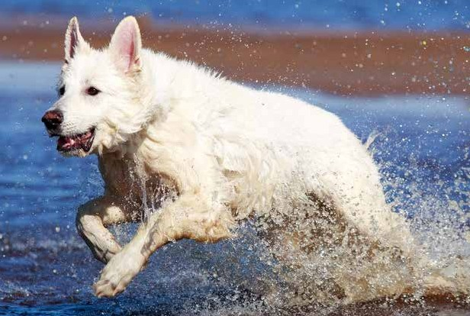

*“The PlexiDor dog door is the greatest thing, it really is. It frees you and your dogs, and you will experience very little heat loss.”*

*Eva Kaufman – Ontario, Canada*

94

Dog Breeds of the World

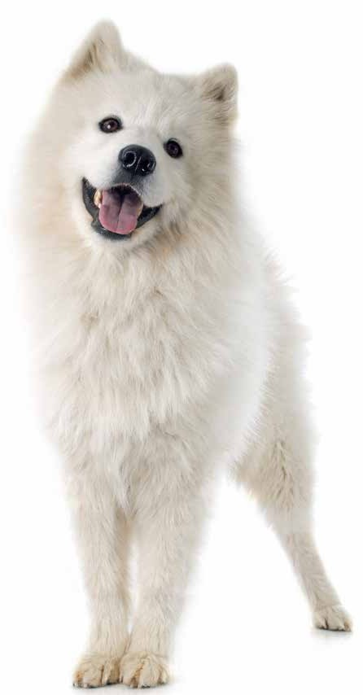

## *Countries represented in the book*

Afghanistan 6

Australia 7

Belgium 8

Brazil 12

Canada 13

China 16

Croatia 21

Cuba 22

Denmark 23

Egypt 24

Finland 26

France 28

Germany 34

Hungary 40

Ireland 44

Israel 47

Italy 50

Japan 53

Korea 56

Malta 57

Mexico 58

Morocco 60

The Netherlands 61

Norway 63

Papua New Guinea 65

Portugal 66

Russia 68

Spain 72

Sweden 73

Switzerland 76

United Kingdom 80

USA 85

Zimbabwe 92

**Get your own copy of this book**

### Visit: [www.plexidors.com](http://www.plexidors.com/) Call: 800-283-8045

* Secure with cylinder locks and steel security plate.

The door keeps unwanted guests out. Insert the key to lock or unlock the door. The lock features a steel cam and lock cylinder.

The steel security plate can only be unscrewed and removed from the inside.

* Energy-Efficient

The panels are molded to form a dual thermo-pane effect for excellent insulation. Both panels are lined on all four sides wih snug-fitting high-density nylon pile weather seal to provide superior draft control. Doors close tight, keeping the heating and cooling inside your home. Saves money on your energy bill, and is ideal for extreme climates!

*\*Size XL is a solid 3/8” thick sheet of acrylic.*

* Never change flaps again

Rigid, high-impact, shatter-resistant acrylic panels do not require costly vinyl replacement flaps.

* Two-Way Self-Closing

Large and small pets can use the same door. Panels open smoothly with a gentle push and close automatically. Heavy duty springs are concealed within the main frame.

* Close Quietly

Won’t disturb you, or frighten your pet. The panels are insulated and lightly tinted yet see-through, creating a window for your pet.

* Heavy-Duty Frames

Hardened aluminum won’t rust, crack or warp. Attractive satin finish, or baked on white or brown finish.

***“In the year 2000, we bought a PlexiDor pet door. Since then it has been used continuously by two large dogs, often at top speed. This has been the best money we ever spent.”***

***Alma Taylor - Washington***

**The PlexiDor**® **Promise**

#### You must be completely satisfied with your door!

**Every PlexiDor**® **comes with a 90 day Money Back Guarantee, and a 5-Year Warranty!**

We think you will agree that PlexiDor® Pet Doors are the best looking, best engineered, and best value you have ever seen in a pet door.

However, if for any reason you are not completely satisfied with your purchase, just return it within 90 days and we will refund the purchase price in full. Shipping charges are not refundable.

PlexiDor® Pet Doors are covered by a 5 year limited warranty. Any defective part will be repaired or replaced without expense to the customer, including standard shipping charges, for five years from the purchase date. Local labor is not covered. (The warranty covers residential use only.)

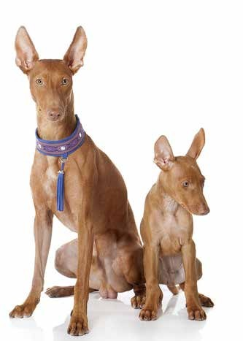

*“Sincere thanks for your wonderful product. Your excellent service is also appreciated!”*

*Jim D.I. Dunnet, British Columbia, Canada*